MATHEMATICS WEEKLY/UNIT PLANNER
Level: Gr 3/4 Term: 2 2019 Weeks: 3-6
Teachers: Leonie, Fran and Marg
Dimension: Measurement and Geometry
Specific Focus for Unit: Measurement - Time
Victorian Curriculum Content Descriptions  http://victoriancurriculum.vcaa.vic.edu.au/mathematics/introduction/rationale-and-aims | Key Concepts  https://drive.google.com/file/d/0B3ydL4IWBSAbbk5laWtLOEprYXc/edit
Yr 2:  Tell time to the quarter-hour, using the language of 'past' and 'to' (VCMMG117)  Yr 3:  Tell time to the minute and investigate the relationship between units of time (VCMMG141)  Yr 4:  Convert between units of time (VCMMG167)  Use am and pm notation and solve simple time problems (VCMMG168)  Yr 5:  Compare 12- and 24-hour time systems and convert between them (VCMMG197) | Duration of time  Sensing the extent of a period of time, e.g. a minute.  Time Telling  Using an instrument to measure time:  • analogue  • digital.  Time Elapsed  Calculating time from a starting point to an end point.
Reporting Statements:

Grade 3 - Tell the time to the nearest minute.
Grade 4 - Solve simple time problems.

Pre-Assessment | Insights | Learning Intentions & Success Criteria
Task:  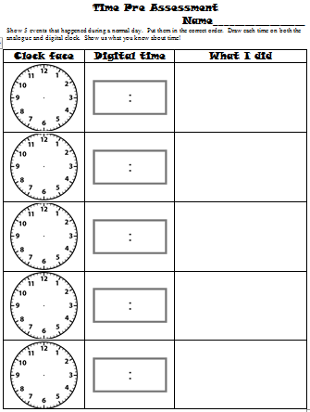 | All o’clocks correct  Most half pasts correct  Times were sequenced in order  Many students didn’t discriminate length of hands  Lots of difficulty with 3.20 in hands  Not matching big hand with multiples of 5  Most students matched correct digital with analogue  Most students kept to ‘safe’ times | We are learning to tell the time in hours and minutes with both analogue and digital clocks.  Success Criteria: I will be successful if…  I can identify the different parts of a clock and what they do (analogue and digital).  I can tell the time accurately.  I can explain how hours, minutes and seconds connect to each other.  We are learning to solve problems involving time.  Success Criteria: I will be successful if…  I am able to use a clock to calculate the time between events.

SESSION NUMBER  LEARNING INTENTION  & SUCCESS CRITERIA | TOOL SESSION  A short, sharp task relating to fluency in mental computation or the focus of the lesson.  WHOLE CLASS FOCUS  Sets the scene/context for what students do in the investigation session. | INVESTIGATION SESSION  Extended opportunity for students to work in pairs, small groups or individually. A time for the teacher to probe children’s thinking or work with a small group for part of the time. | REFLECTION  Focused questions and summary to draw out the mathematics and assist children to make links. | TEACHER ASSESSMENT  We are looking for...
Session 1  LEARNING INTENTION  We are learning to tell the time in hours and minutes with both analogue and digital clocks.  SUCCESS CRITERIA  I will be successful if…  I can identify the different parts of a clock and what they do (analogue and digital).  I can tell the time accurately.  I can explain how hours, minutes and seconds connect to each other. | TOOL SESSION  Tables at Tables (number fact practise) Extra brag tags for months  WHOLE CLASS FOCUS  Videos – You Tube  https://www.youtube.com/watch?v=74I0M0RKNIE&list=PLDQlSh98XAywTatIwQKMAyPa4rtMl6Ft5&index=1  ‘History of Keeping Time’  https://www.youtube.com/watch?v=8RJzoyIVzV8&list=PLDQlSh98XAywTatIwQKMAyPa4rtMl6Ft5&index=2  ‘Learn How to Tell Time on a Clock’  Stop at 4:34 (irrelevant stuff after)  Watch, then watch again and have students write key vocab words on whiteboards. Add these to maths wall.  https://www.youtube.com/watch?v=ENOYemdWU08&t=115s  ‘Digital Clock Song for Kids Jack Hartmann’ – very corny – prob’ly just watch half!  Demonstration: Strip number lines turned into clocks  Interactive: ‘Teaching Clock’  http://www.visnos.com/demos/clock  Use this clock to teach time concepts.  Broken clock activity – students must work out the time using only the hour hand (minute hand is ‘broken off’) see Marg for how to ‘break’ the Teaching Clock. | INVESTIGATION  Task: Broken Clocks  Students identify the time to the quarter hours and write beneath the clocks.  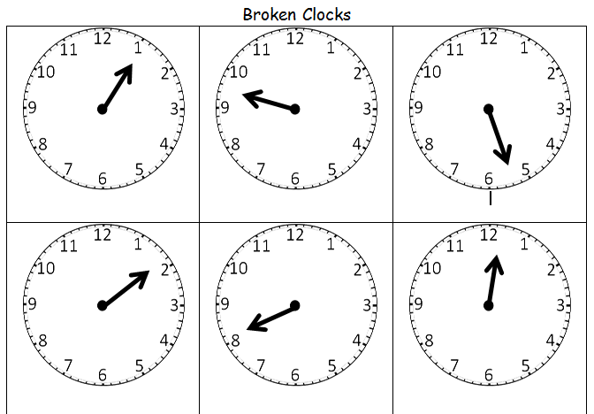  Extending Prompts:  Write both digital and clock face time.  Enabling Prompts:  Look carefully at the hand and remember the cookie from the video (rewatch).  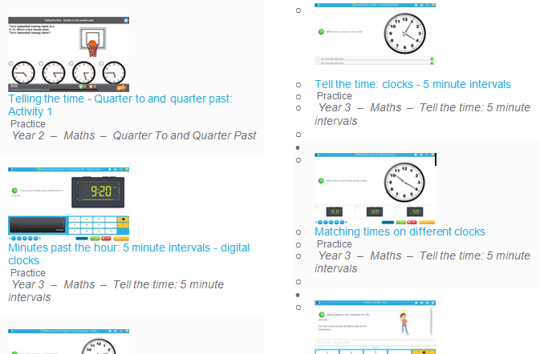 | REFLECTION  (20 mins before lesson end)  How have you been successful?  How do you know when you’ve got this?  Who’d like a study buddy to help them finish?  What’s the tricky bit we have to watch for? (¼ to)  Keep working for 10 more minutes then we’ll correct together  Study Ladder: ‘Time’ and ‘Time for Champions’ pods | ASSESSMENT  Correct as a class and collect sheets for assessment

Session 2  LEARNING INTENTION  We are learning to tell the time in hours and minutes with both analogue and digital clocks.  SUCCESS CRITERIA  I will be successful if…  I can identify the different parts of a clock and what they do (analogue and digital).  I can tell the time accurately.  I can explain how hours, minutes and seconds connect to each other. | TOOL SESSION  Tables at Tables (number fact practise) Extra brag tags for months  WHOLE CLASS FOCUS  Videos – You Tube  https://www.youtube.com/watch?v=gEStq1e1Qrc  ‘Seconds, Minutes and Hours by StoryBots’ – quick fun song  https://www.youtube.com/watch?v=njpsJUFX-Vk  ‘Telling Time to the Minute’  Interactive: ‘Teaching Clock’  http://www.visnos.com/demos/clock  Use this clock to teach time to the minute. Have students use personal white boards to draw and write several examples.  (Can also use the miniature clocks) | INVESTIGATION  Task: Reading the Time Accurately  Students identify the time and write beneath the clocks  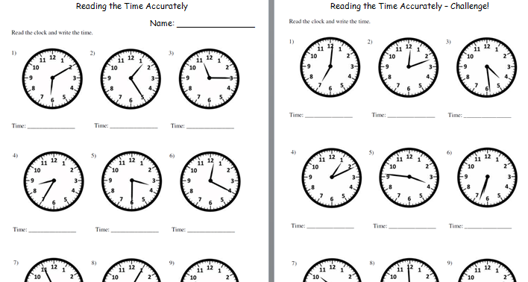  Extending Prompts:  Write both digital and clock face time.  Enabling Prompts:  Look at the hour hand first then use the minute hand to count by fives. | REFLECTION  (20 mins before lesson end)  Finish the sentence: I’ve learnt that…  Who’s got questions?  Revisit success criteria and use the ‘Where Am I At with My Learning?’ poster:  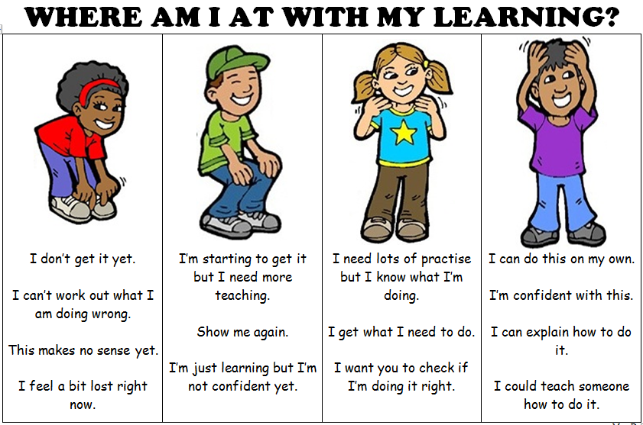  Keep working for 10 more minutes then we’ll correct together  Study Ladder: ‘Time’ and ‘Time for Champions’ pods | ASSESSMENT  Correct as a class and collect sheets for assessment

Session 3  LEARNING INTENTION  We are learning to solve problems involving time (calendars and clocks).  SUCCESS CRITERIA  I will be successful if…  I am able to use a clock to calculate the time between events. | TOOL SESSION  Tables at Tables (number fact practise) Extra brag tags for months  WHOLE CLASS FOCUS  Interactive: ‘Teaching Clock’  http://www.visnos.com/demos/clock  Problem Solving Time Cards  Use the clock to work through several problems from the cards.  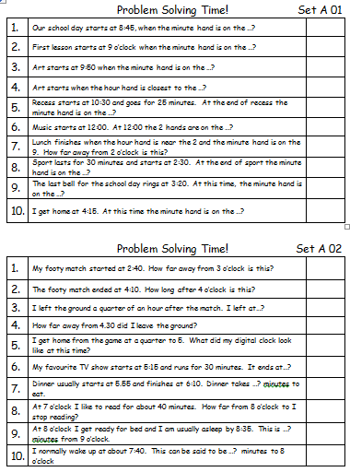 | INVESTIGATION  Task: Problem Solving Time!  Students work through the problems on the cards, self correcting with the answer cards.  Extending Prompts:  Write some time problems of your own for others to do.  Enabling Prompts:  What could you use to help work out the problem? (re-reading, drawing, a mini clock or the teaching clock) | REFLECTION  (20 mins before lesson end)  What tricky questions would you like to talk about together?  What parts of time do you think we might need to do more of?  Which bits are you confident of?  Study Ladder: ‘Time’ and ‘Time for Champions’ pods | ASSESSMENT  Are students able to work out what the problem is asking?  What areas are students still having difficulty with?  Are students able to use play clocks and other equipment to help them?

