Investigating September
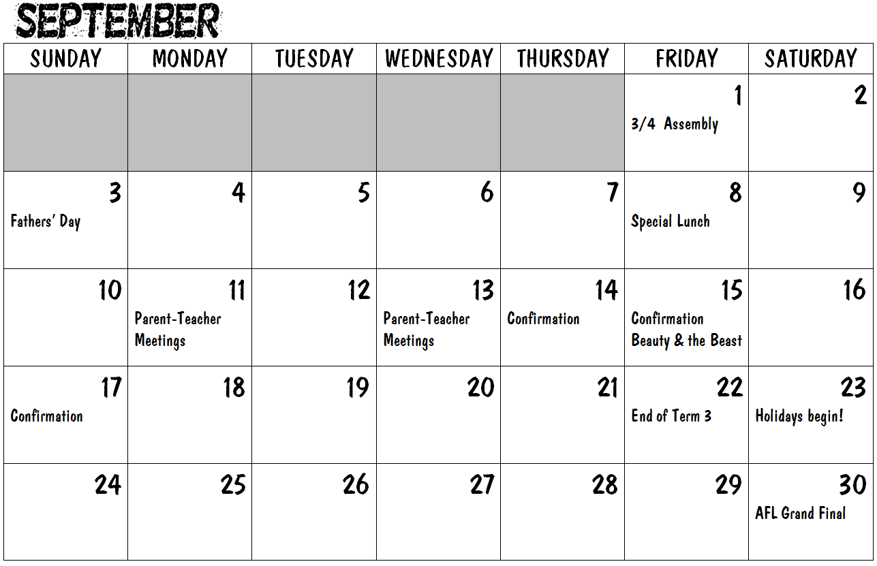

Investigating September
On what day does September begin?
What date is the AFL Grand final?
What day is the special lunch?
What date is the 2nd Sunday?
What day is the 28th?
What is the date 4 days after 3/4 Assembly?
How many days in September?
What’s happening on the 4th Friday of the month?
How many Saturdays does September have?
What’s the date of our last day of term?
On what nights are parent-teacher meetings?
How many Confirmation celebrations are there?
What day is the 19th?
What date is the 4th Monday?
How many Mondays does September have?
Investigating September Answers
 | On what day does September begin? | Friday
 | What date is the AFL Grand final? | 30th
 | What day is the special lunch? | Friday
 | What date is the 2nd Sunday? | 10th
 | What day is the 28th? | Thursday
 | What is the date 4 days after special lunch? | 5th
 | How many days in September? | 30
 | What’s happening on the 4th Friday of the month? | End of Term 3
 | How many Saturdays does September have? | 5
 | What’s the date of our last day of term? | 22nd
 | On what nights are parent-teacher meetings? | Monday 11th & Wednesday 13th
 | How many Confirmation celebrations are there? | 3
 | What day is the 19th? | Tuesday
 | What date is the 4th Monday? | 25th
 | How many Mondays does September have? | 4

