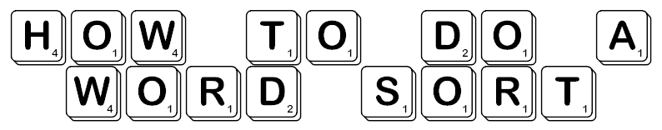

- Collect the word sort sheet, the A3 sheet, 2 glue sticks, 2 scissors, textas.

- Find a place where all 3 of you can sit around the A3 sheet.

- Cut out the words as quickly and neatly as possible.

- Lay out all the words and read through each one.

- Talk about similarities and differences, the patterns you see, the connections between the words.

- Decide together how you’re going to sort the words and write your categories on the sheet.

- Place the words into the categories you’ve made. Check to see if you’re happy with where each word is. Do you need another category?

- Write some sentences to state what you’ve found.

- Be ready to share and talk about what you’ve found out.

- We’ll keep all sheets in the A3 ‘Word Sorts’ folder.

