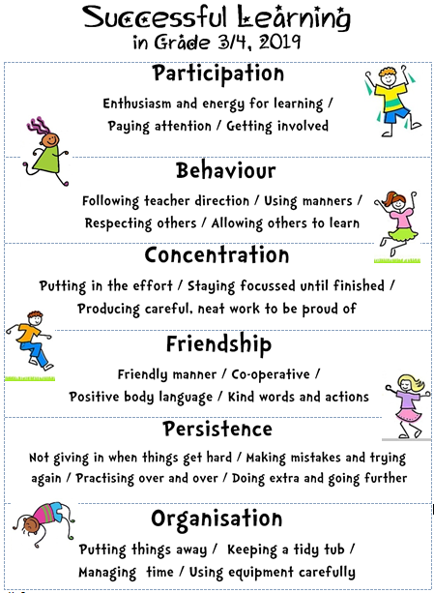 | What am I good at? What are my learning strengths?  ----------------------------------  ----------------------------------  ----------------------------------  What are my goals?  ----------------------------------  ----------------------------------

What am I good at? What are my learning strengths?

----------------------------------

----------------------------------

----------------------------------

What are my goals?

----------------------------------

----------------------------------

