Reading the Time Accurately

Name: _______________
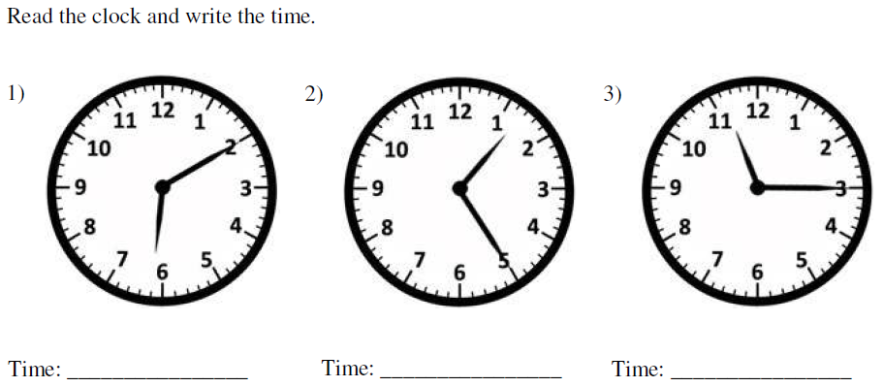

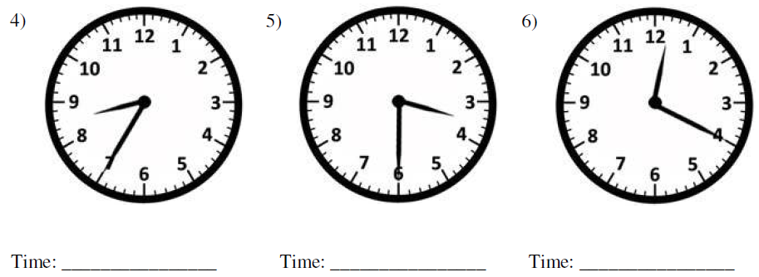

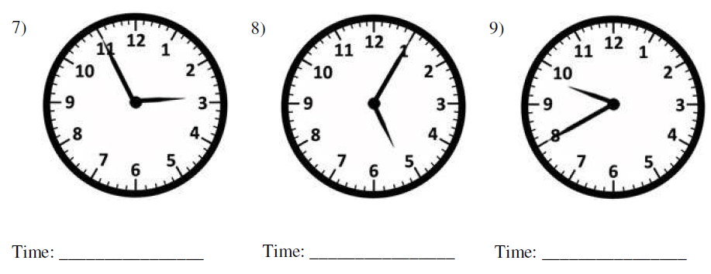
MargD

Reading the Time Accurately – Challenge!

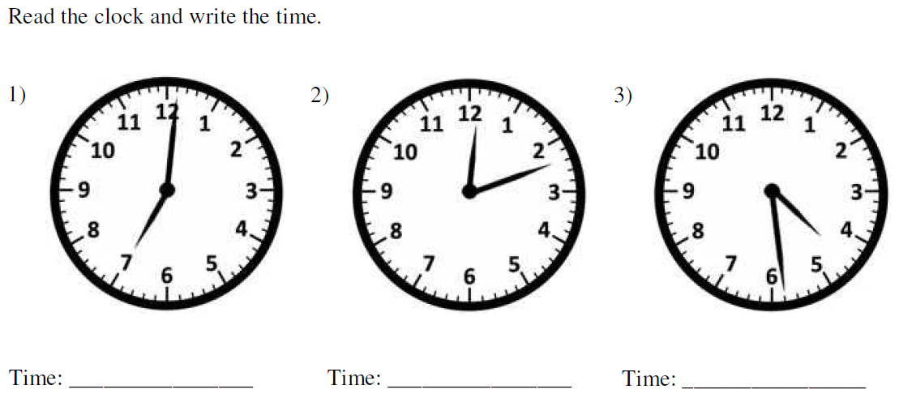

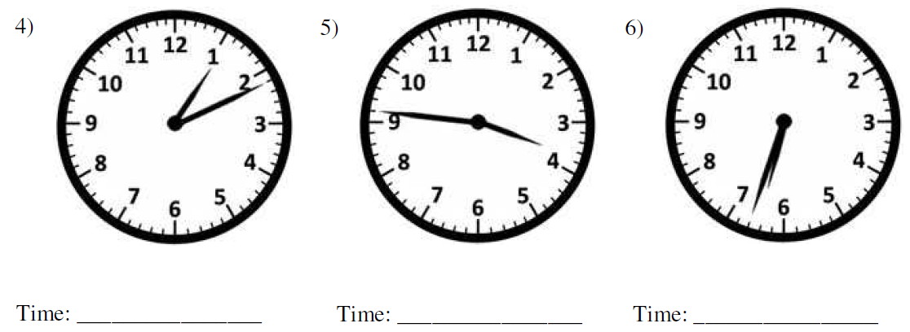

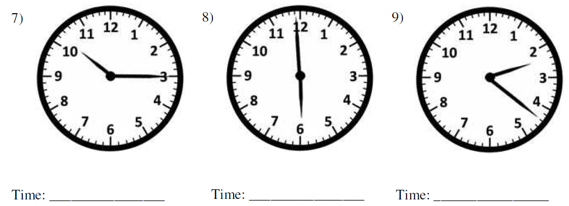
MargD

Reading the Time Accurately Answers

Name: _______________
6:10 or 10 past 6 1:25 or 25 past 1 11:15 or ¼ past 11

8:35 or 25 to 9 3:30 or ½ past 3 12:20 or 20 past 12

2:55 or 5 to 3 5:05 or 5 past 5 9:40 or 20 to 10
MargD

Reading the Time Accurately – Challenge! Answers

7:01 or 1 past 7 12:12 or 12 past 12 4:29 or 29 past 4

1:11 or 11 past 1 3:46 or 14 to 4 6:32 or 28 to 7

10:15 or 15 past 10 5:59 or 1 to 6 2:22 or 22 past 2
(¼ past 10)
MargD

