Plan for Writing a Persuasive Text
Issue:

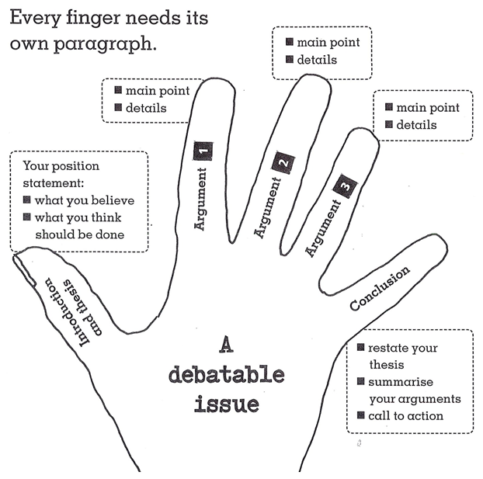
Arguments and Evidence (in dot points)

