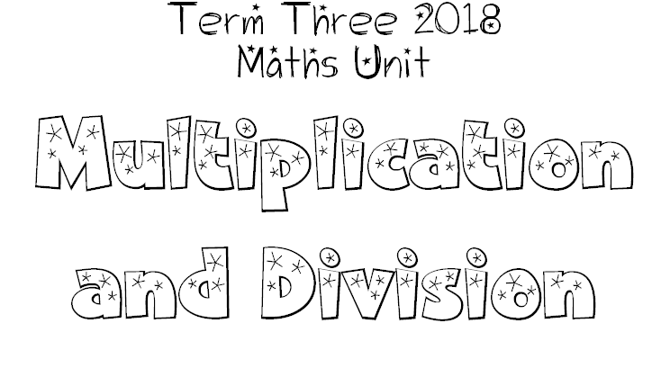
We can learn our times tables and investigate number sequences.
I will be successful if:
I can identify the repeating sequence of numbers when counting by 3s, 4s. 5s, 6s, 7s, 8s, 9s, 10s. (Extension 11s, 12s).
I can earn my times table ‘brag tags’.

We are learning various methods of multiplying and dividing numbers.
I will be successful if:
I can use arrays to make discoveries about numbers.
I can use horizontal and vertical methods of solving problems.
I can use the ‘distributive’ property to solve a problem.

We are learning how multiplication and division are related.
I will be successful if:
I can show how division is the ‘inverse’ of multiplication.
I can solve division problems.
I can use an array to show 2 multiplication and 2 division problems.

We are learning the commutative, null factor and identity properties of multiplications.
I will be successful if:
I can prove that swapping the numbers around does not change the product (the answer). eg. 3 x 6 gives the same product as 6 x 3 (Commutative property).
I can identify rules that work when multiplying by 0 and 1.

