MATHEMATICS WEEKLY/UNIT PLANNER
Level: Gr 3/4 Term: 2 2017 Weeks: 7/8-11 (and 2 weeks in Term III)
Teachers: Sinead, Kellie and Marg
Dimension: Measurement and Geometry
Specific Focus for Unit: Measurement
Victorian Curriculum Content Descriptions  http://victoriancurriculum.vcaa.vic.edu.au/mathematics/introduction/rationale-and-aims | Key Concepts  https://drive.google.com/file/d/0B3ydL4IWBSAbbk5laWtLOEprYXc/edit
Yr 2:  Compare and order several shapes and objects based on length, area, volume and capacity using appropriate uniform informal units (VCMMG115)  Compare masses of objects using balance scales(VCMMG116)  Yr 3:  Measure, order and compare objects using familiar metric units of length, area, mass and capacity (VCMMG140)  Yr 4:  Use scaled instruments to measure and compare lengths, masses, capacities and temperatures (VCMMG165)  Compare objects using familiar metric units of area and volume (VCMMG166)  Yr 5:  Choose appropriate units of measurement for length, area, volume, capacity and mass (VCMMG195)  Calculate the perimeter and area of rectangles and the volume and capacity of prisms using familiar metric units (VCMMG196) | Unit of Measure  Recognising:  - the unit used to measure an attribute must be uniform in order for the measurement to be meaningful  - the larger the unit, the smaller the measure  - a system of regularly spaced intervals, i.e. a scale beginning with informal units such as paper clips or cubes, moving towards formal instruments such as rulers, thermometers  Equivalence and Conversion  - The relationship between standard units of measure, e.g. 100 centimetres is equivalent to 1 metre.  - When we know the equivalence or relationship between units, we can convert (conversion), e.g. 2 metres and 35 centimetres is the same as 235 centimetres.

Pre-Assessment | Insights | Learning Intentions
Task:  “Here’s a shipping container.” – Students suggest different ways of measuring the shipping container.  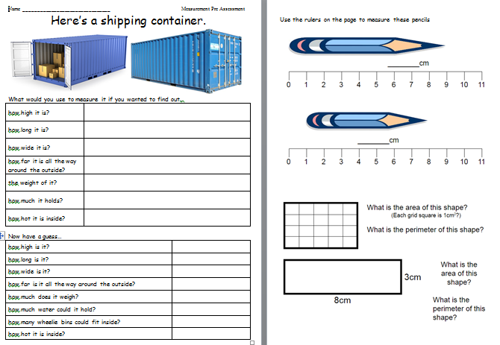 | Some familiarity of measurement terminology but not necessarily matching the right uses.  Very little knowledge of perimetre or area.  Due to the size of the unit – some assessment items (eg. area, temperature) will be covered in later units and not in this one.  Edit: extra area lessons added – we were on a roll! – see bottom of planner | We can measure, order and compare objects using familiar metric units  - of length and perimetre. (mm, cm, m)  - of mass. (gm, kg)  - of capacity and volume (mL, L)  The way we measure needs to be uniform for measurements to be meaningful.  We can convert between standard units of measure.

SESSION NUMBER  KEY IDEA  LEARNING INTENTION | TOOL SESSION  A short, sharp task relating to fluency in mental computation or the focus of the lesson.  WHOLE CLASS FOCUS  Sets the scene/context for what students do in the independent session. | INVESTIGATION SESSION  Extended opportunity for students to work in pairs, small groups or individually. A time for teacher to probe children’s thinking or work a small group for part of the time. | REFLECTION  Focused teacher questions and summary to draw out the mathematics and assist chn to make link/s. | TEACHER ASSESSMENT  We are looking for...
Session 1  LEARNING INTENTION  We can measure, order and compare objects using familiar metric units. | TOOL SESSION  20 Sum Challenge  WHOLE CLASS FOCUS  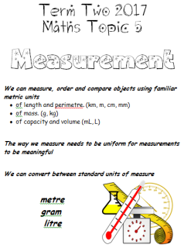  Introduction of topic and guidance through the learning intentions on the cover sheet.  Introduce the words  Length, Mass, Capacity and discuss what we know about these.  Task: Grocery Sort  Sort items according to how they are measured: length, mass, capacity  (Sultanas, tinned vegetables, cordial, cereal, salt, flour, glue stick, ball of string, foil, sandwich bags, laundry powder, laundry liquid, superglue, nail polish, garbage bags, various sizes of soft drink ) | INVESTIGATION  Task: Words and Pictures charts  Working in groups and rotating around each chart, students use poster paper to create 3 charts - Length chart, Mass chart, Capacity chart  Each chart should contain pictures or drawings of objects measured by that attribute and vocabulary related to that attribute.  (catalogues a good source for pictures)  Extending Prompts:  Students use Jenny Eather’s Maths Dictionary to add information to pages.  http://www.amathsdictionaryforkids.com/  Enabling Prompts:  Help students identify the part of the product label that indicates measurement. | REFLECTION  Video – You Tube  https://www.youtube.com/watch?v=ZZYnERZe3Cg&index=30&list=PLDQlSh98XAywTatIwQKMAyPa4rtMl6Ft5  Hunting for Properties: Crash Course Kids #9.1 | ASSESSMENT  Check how students sort the products.  Are they looking in the correct places for the measurement?  Are students familiar with measurement units?

Session 2  LEARNING INTENTION  We can measure, order and compare objects using familiar metric units.  The way we measure needs to be uniform for measurements to be meaningful. | TOOL SESSION  20 Sum Challenge  WHOLE CLASS FOCUS  Video – You Tube  https://www.youtube.com/watch?v=9DjYQ41a3Kk  Bill Nye the Science Guy S05E17 Measurement  20 minutes in length – first minute can be skipped. | INVESTIGATION  Task: Video Information Gathering  There’s a lot going on in this video so it may be helpful to break it up and stop after each segment.  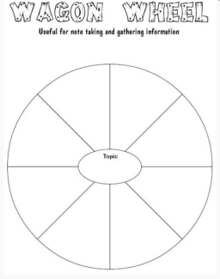  Use a graphic organizer such as a wagon wheel (A3 copies) to make notes on what we’re learning. | REFLECTION  Place exemplar wagon wheel examples on maths wall. | ASSESSMENT  Can students sort measurement information into groups?
Session 3  LEARNING INTENTION  The way we measure needs to be uniform for measurements to be meaningful.  We can convert between standard units of measure. | TOOL SESSION  20 Sum Challenge  WHOLE CLASS FOCUS  Video – You Tube  https://www.youtube.com/watch?v=1TlCcW_mugs  Metric System - explained simply  After video add statements of what we learned to maths wall  Powerpoint – “The Metric Staircase”  https://docs.google.com/presentation/d/15Vf6A2gc4-p06btd7E5s85NKLckI9mf2DDv9PKeUAHc/edit#slide=id.p3 | INVESTIGATION  Task: Individual Fact Posters  Students complete individual fact posters in their maths folder reflecting what they’ve learned so far about metric units. Title should be ‘Our Metric System’ with statements about how we use metre, gram and litre to measure length, mass and capacity. Students should use their wagon wheel to give them ideas.  Extending Prompts:  How might we measure other aspects such as temperature, angle, electrical charge?  Enabling Prompts:  Would it help to watch that part of the video again? | REFLECTION  Sharing exemplar student work. | ASSESSMENT  Check individual posters for accuracy of content.

Session 4  LEARNING INTENTION  We can measure, order and compare objects using familiar metric units.  Focus: Length | TOOL SESSION  20 Sum Challenge  WHOLE CLASS FOCUS  Introduce focus on length  Video – You Tube  https://www.youtube.com/watch?v=mhtpFvNbiPE Metric Length - then click on link for questions to supplement this vid | INVESTIGATION  Task: ‘People of Various Heights’  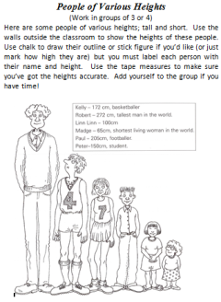  Students use the walls outside the classroom to show the heights of people. Use chalk to draw their outline or stick figure (or just mark how high they are). Label each person with their name and height. Use tape measures for accuracy. (may need to stand on chairs for some)  Extending Prompts:  Can you convert the cm into metres?  Enabling Prompts:  Using peer coaches | REFLECTION  Get children to take photos of their process and create a Pic Collage at the end.  Study Ladder Length pod. | ASSESSMENT  Oral assessment – get selected students to complete the following:  I was able to…  I learnt that…  I can … (refer to learning intentions)  Next time I would...
Session 5  LEARNING INTENTION  We can measure, order and compare objects using familiar metric units.  Focus: Length | TOOL SESSION  20 Sum Challenge  WHOLE CLASS FOCUS  TV Sale!  (need some tv catalogues/online stores examples)  Show students how televisions are measured by the diagonal length of the screen.  Challenge them to find out the size of their tvs and monitor screens at home | INVESTIGATION  Task: Worksheet ‘TV Sale  Extending Prompts:  Check the website of the store to see if the largest are always the most expensive. How do they measure the curved tvs?  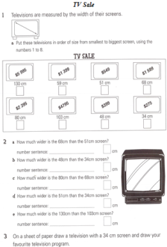  Enabling Prompts:  Small group lead through | REFLECTION  Correcting worksheet together  Study Ladder Length pod | Extension  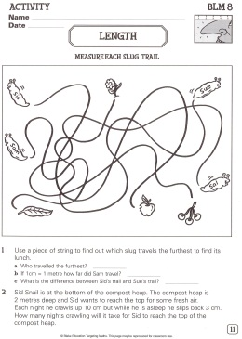

Session 6  LEARNING INTENTION  We can measure, order and compare objects using familiar metric units.  Focus: Length and Perimetre  The way we measure needs to be uniform for measurements to be meaningful. | TOOL SESSION  20 Sum Challenge  WHOLE CLASS FOCUS  Introduce term ‘perimetre’  Video – You Tube  https://www.youtube.com/watch?v=n5ULJ_kcFzI  Adam Up Maths - Perimeter Song – very simple song with good visual examples. | INVESTIGATION  Task: Shape Perimeters  Model using a geoboard and rubber bands to make shapes then transfer these onto grid paper and calculate the perimeter.  Sharing a geoboard between 3-4 people, students use the same process.  Examples of shapes that could be made:  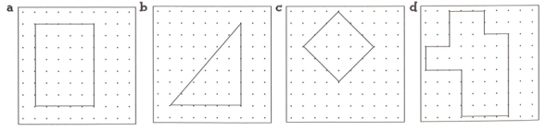  Extending Prompts:  Make your shapes more complex by increasing the number of corners  Try doing it on blank paper.  Enabling Prompts:  Simplify your shapes and keep the lines straight  Worksheet: ‘Measuring Perimetre’  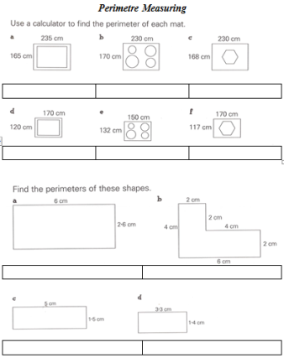 | REFLECTION  Display some of the grid paper examples on the maths wall.  Length Fact Book – Students fill in a book to consolidate facts about measuring length.  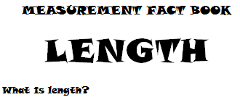  Study Ladder Length pod | ASSESSMENT  Have the students shown a good understanding in the Length Fact Book?  Keep worksheet for assessment data

Session 7  LEARNING INTENTION  We can measure, order and compare objects using familiar metric units  Focus: Mass  The way we measure needs to be uniform for measurements to be meaningful. | TOOL SESSION  20 Sum Challenge  WHOLE CLASS FOCUS  Quick Quiz:  Which would weigh more - one kilogram of feathers or one kilogram of bricks?  Videos – You Tube  https://www.youtube.com/watch?v=-Jh71YY5i38  Adam Up Maths - Metric Mass Song  https://www.youtube.com/watch?v=2wW-Ssk2BjU  Metric Units: Mass | INVESTIGATION  Task: ‘Stations’  Student work in groups of 3 or 4 to complete the following 4 stations:  Measuring station – using weigh scales, students measure the weight of various groceries and record in their books.  Ordering station – students order a set of groceries from lightest to heaviest using balance scales and weight scales and record in their books.  Comparing station – students compare groceries using hand hefting and record in their books.  Balancing station – students using differing materials (paper clips, centicubes, counters, planks) to make specific weights by using balance scales, and record in their books.  Extending Prompts:  How can you challenge yourself?  Enabling Prompts:  Peer coaching | REFLECTION  Study Ladder Mass pod  Take photos of groups for pic collage sharing on maths wall | ASSESSMENT  Check the statements the students have made in their books from each station.

Session 8  LEARNING INTENTION  We can measure, order and compare objects using familiar metric units.  Focus: Mass | TOOL SESSION  20 Sum Challenge  WHOLE CLASS FOCUS  Videos – You Tube  https://www.youtube.com/watch?v=0ArAx97-94Q  Top 10 Heaviest Animals. | INVESTIGATION  Task: Worksheet ‘Animals and their Masses’  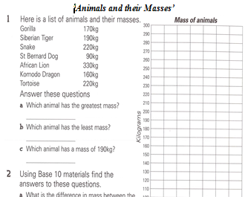 | REFLECTION  Mass Fact Book – Students fill in a book to consolidate facts about measuring mass.  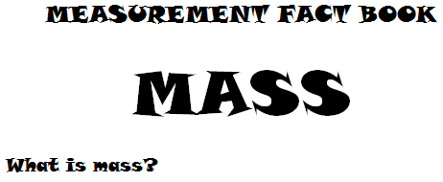  Study Ladder Mass pod | ASSESSMENT  Have the students shown a good understanding in the Mass Fact Book?
Session 9  LEARNING INTENTION  We can measure, order and compare objects using familiar metric units  Focus: Volume | TOOL SESSION  20 Sum Challenge  WHOLE CLASS FOCUS  Fruit Punch  Show students how to measure accurate quantities of the 3 liquids to make their own glass of fruit punch during the lesson  50 ml of juice  100 ml of lemonade  100 ml of dry ginger  1 strawberry (chopped)  3 slices of bananas | INVESTIGATION  Task: Make a Measuring jug  Using a 2 litre bottle (soft drink or milk jug,  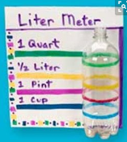  students use water, measuring containers, tape and textas to mark off measurements. Use 200ml increments. Eg. (but with metric)  Extending Prompts:  Mark in 100ml intervals  Enabling Prompts:  Mark the litre first | REFLECTION  Study Ladder Volume pod | Extension  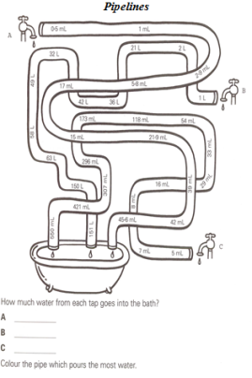

Session 10  LEARNING INTENTION  We can measure, order and compare objects using familiar metric units  Focus: Volume  The way we measure needs to be uniform for measurements to be meaningful. | TOOL SESSION  20 Sum Challenge  WHOLE CLASS FOCUS  Videos – You Tube  https://www.youtube.com/watch?v=ZUcXAr2gSO4  Show Capacity-volume demonstration  This experiment could be tested in the classroom (if you’re game!) | INVESTIGATION  Task: Capacity and Volume worksheet  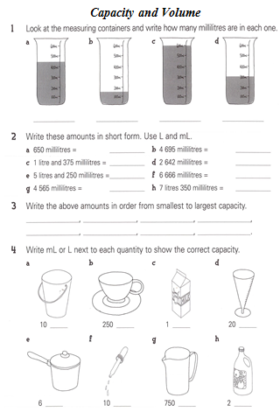 | REFLECTION  Volume Fact Book – Students fill in a book to consolidate facts about measuring volume.  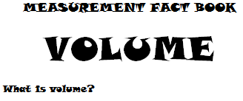  Study Ladder Volume pod | ASSESSMENT  Have the students shown a good understanding in the Volume Fact Book?
Session 11  LEARNING INTENTION  We can convert between standard units of measure | TOOL SESSION  20 Sum Challenge  WHOLE CLASS FOCUS  Video – You Tube  https://www.youtube.com/watch?v=djTNUp4XIRo&t=93s  Metric System Conversions Song | Measurement by Numberock  Powerpoint – ‘Metric Conversion’  https://docs.google.com/presentation/d/1QfFAKhA7XhDhJOyVbEGgU2SKbtsvF3sv_v0csOqw7Xg/edit#slide=id.p3 | INVESTIGATION  Task: Metric Conversion worksheet  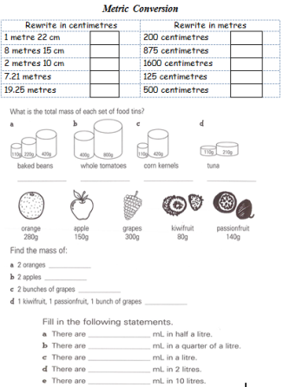  Extending Prompts:  How can you challenge yourself and a partner?  Enabling Prompts:  Small group lead through | REFLECTION  Macmillan problem solving cards – see the end of the ‘Metric Conversion’ powerpoint | ASSESSMENT  Keep worksheet for assessment data

Because we can, we’re extending this unit to include ‘area’. Our team will spend the first couple of weeks in Term III finishing off our measurement unit. We will include a few extra sessions on area. During this time we will also try to administer the pre-assessments for all the units planned for this term.

Session 12  LEARNING INTENTION  We can measure, order and compare objects using familiar metric units.  Focus: Area | TOOL SESSION  Tables at Tables (number fact practise)  WHOLE CLASS FOCUS  Introduce focus on area  Revise our work on Length and perimetre. We can measure a line, around a shape but what about the space inside a shape?  Video – You Tube  https://www.youtube.com/watch?v=qU8aWpRd6Qw  Perimeter Around The Area  or  https://www.youtube.com/watch?v=2p_YqW8xOIg  Adam Up Maths - Area Song | INVESTIGATION  Task: ‘Geo Board Areas’  Students use the geo boards to revise what we did with perimetre and extend into area. Students make a shape with the geo board then transfer this onto graph paper and count up the squares. Don’t allow diagonals at first then pose the problem of how we count up the squares when a shape has diagonal lines and we can’t count the squares accurately. Tell students we’ll be tackling this problem in a later session.  Examples of shapes that could be made:  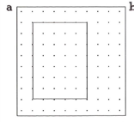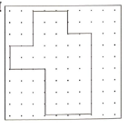  Extending Prompts:  Make your shapes more complex by increasing the number of corners  Try doing it on blank paper.  Enabling Prompts:  Simplify your shapes and keep the lines straight | REFLECTION  Get children to take photos of their process and create a Pic Collage at the end.  Study Ladder Length pod. | ASSESSMENT  Check student work

Session 13  LEARNING INTENTION  We can measure, order and compare objects using familiar metric units.  Focus: Area | TOOL SESSION  Tables at Tables (number fact practise)  WHOLE CLASS FOCUS  Video – You Tube  https://www.youtube.com/watch?v=xCdxURXMdFY  Math Antics – Area  This video has a lot in it so be prepared to pause and practise. Stop about half way through when it starts on Triangles – do this in the next session | INVESTIGATION  Task: Area of Surfaces Outside  Take students outside with chalk, rulers and measuring tapes. Student choose various panels on the walls (different sized bricks, panels – rectangular, square shapes) and write the area on for others to check.  Extending Prompts:  Use the rolling metre measure to find the area of the basketball court.  Enabling Prompts:  Use the shapes that have already been measured so you can check. | REFLECTION  Get children to take photos of their process and create a Pic Collage at the end.  Study Ladder Area pod. | ASSESSMENT  Oral assessment – get selected students to complete the following:  I was able to…  I learnt that…  I can … (refer to learning intentions)  Next time I would...
Session 14  LEARNING INTENTION  We can measure, order and compare objects using familiar metric units.  Focus: Area | TOOL SESSION  Tables at Tables (number fact practise)  WHOLE CLASS FOCUS  Video – You Tube  https://www.youtube.com/watch?v=xCdxURXMdFY  Math Antics – Area  Review what we’ve done with this video and continue on to the second half covering the area of triangles. | INVESTIGATION  Task: Geo Board Area  Again, use the geo boards to make triangles and transfer these onto graph paper then calculate the areas.  Use all three types of triangles – right angle, acute, obtuse | REFLECTION  Study Ladder Area pod.  I was able to…  I learnt that…  I can … (refer to learning intentions)  Next time I would... | ASSESSMENT  Check student work

