Brag Tag
~ Grade 3 & 4 MD MdJ ~
Term III 2019
 | Grade | 9 x Tables | 6 x Tables | 8 x Tables | 12 x Tables | 7 x Tables | 10 Shapes | 6 Solids | Measurement | Square Numbers
 | 3
 | 3
 | 3
 | 3
 | 3
 | 3
 | 3
 | 3
 | 3
 | 4
 | 4
 | 4
 | 4
 | 4
 | 4
 | 4
 | 4
 | 4
 | 4
 | 4

9 x Tables
Criteria for this Brag Tag
To get this brag tag you need to answer the 9 x tables problem sheet in front of a teacher. You must do this in under 1.30 minutes. Then a teacher will give you 13 table questions you need to answer quickly so we know you’ve got these in your memory.
Procedure for Assessment
To get this brag tag students must:
- Solve all the tables problems on the sheet (in folder) in under 1.30mins
- Answer the following table questions orally (no more than 5 seconds each one)

9x Tables | 9x Tables | 9x Tables | Answers
9 x 6 =  9 x 4 =  9 x 1 =  9 x 3 =  9 x 11 =  9 x 12 =  9 x 2 =  9 x 9 =  9 x 0 =  9 x 5 =  9 x 8 =  9 x 7 =  9 x 10 = | 9 x 6 =  9 x 4 =  9 x 1 =  9 x 3 =  9 x 11 =  9 x 12 =  9 x 2 =  9 x 9 =  9 x 0 =  9 x 5 =  9 x 8 =  9 x 7 =  9 x 10 = | 9 x 6 =  9 x 4 =  9 x 1 =  9 x 3 =  9 x 11 =  9 x 12 =  9 x 2 =  9 x 9 =  9 x 0 =  9 x 5 =  9 x 8 =  9 x 7 =  9 x 10 = | 9 x 6 = 54  9 x 4 = 36  9 x 1 = 9  9 x 3 = 27  9 x 11 = 99  9 x 12 = 108  9 x 2 = 18  9 x 9 = 81  9 x 0 = 0  9 x 5 = 45  9 x 8 = 72  9 x 7 = 63  9 x 10 = 90

6 x Tables
Criteria for this Brag Tag
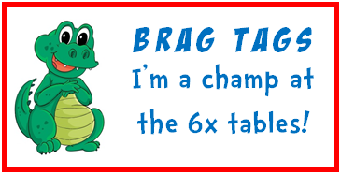 | To get this brag tag you need to answer the 6 x tables problem sheet in front of a teacher. You must do this in under 1.30 minutes. Then a teacher will give you 13 table questions you need to answer quickly so we know you’ve got these in your memory.
Procedure for Assessment
To get this brag tag students must:
- Solve all the tables problems on the sheet (in folder) in under 1.30mins
- Answer the following table questions orally (no more than 5 seconds each one)

6x Tables | 6x Tables | 6x Tables | Answers
6 x 6 =  6 x 4 =  6 x 1 =  6 x 3 =  6 x 11 =  6 x 12 =  6 x 2 =  6 x 9 =  6 x 0 =  6 x 5 =  6 x 8 =  6 x 7 =  6 x 10 = | 6 x 6 =  6 x 4 =  6 x 1 =  6 x 3 =  6 x 11 =  6 x 12 =  6 x 2 =  6 x 9 =  6 x 0 =  6 x 5 =  6 x 8 =  6 x 7 =  6 x 10 = | 6 x 6 =  6 x 4 =  6 x 1 =  6 x 3 =  6 x 11 =  6 x 12 =  6 x 2 =  6 x 9 =  6 x 0 =  6 x 5 =  6 x 8 =  6 x 7 =  6 x 10 = | 6 x 6 = 36  6 x 4 = 24  6 x 1 = 6  6 x 3 = 18  6 x 11 = 66  6 x 12 = 72  6 x 2 = 12  6 x 9 = 54  6 x 0 = 0  6 x 5 = 30  6 x 8 = 48  6 x 7 = 42  6 x 10 = 60

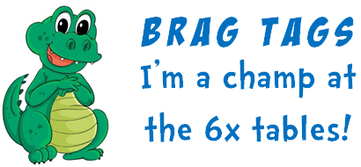

8 x Tables
Criteria for this Brag Tag
To get this brag tag you need to answer the 8 x tables problem sheet in front of a teacher. You must do this in under 1.30 minutes. Then a teacher will give you 13 table questions you need to answer quickly so we know you’ve got these in your memory.
Procedure for Assessment
To get this brag tag students must:
- Solve all the tables problems on the sheet (in folder) in under 1.30mins
- Answer the following table questions orally (no more than 5 seconds each one)

8x Tables | 8x Tables | 8x Tables | Answers
8 x 6 =  8 x 4 =  8 x 1 =  8 x 3 =  8 x 11 =  8 x 12 =  8 x 2 =  8 x 9 =  8 x 0 =  8 x 5 =  8 x 8 =  8 x 7 =  8 x 10 = | 8 x 6 =  8 x 4 =  8 x 1 =  8 x 3 =  8 x 11 =  8 x 12 =  8 x 2 =  8 x 9 =  8 x 0 =  8 x 5 =  8 x 8 =  8 x 7 =  8 x 10 = | 8 x 6 =  8 x 4 =  8 x 1 =  8 x 3 =  8 x 11 =  8 x 12 =  8 x 2 =  8 x 9 =  8 x 0 =  8 x 5 =  8 x 8 =  8 x 7 =  8 x 10 = | 8 x 6 = 48  8 x 4 = 32  8 x 1 = 8  8 x 3 = 24  8 x 11 = 88  8 x 12 = 96  8 x 2 = 16  8 x 9 = 72  8 x 0 = 0  8 x 5 = 40  8 x 8 = 64  8 x 7 = 56  8 x 10 = 80

12 x Tables
Criteria for this Brag Tag
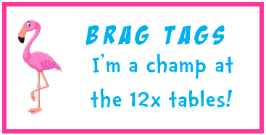 | To get this brag tag you need to answer the 12 x tables problem sheet in front of a teacher. You must do this in under 1.30 minutes. Then a teacher will give you 13 table questions you need to answer quickly so we know you’ve got these in your memory.
Procedure for Assessment
To get this brag tag students must:
- Solve all the tables problems on the sheet (in folder) in under 1.30mins
- Answer the following table questions orally (no more than 5 seconds each one)

12x Tables | 12x Tables | 12x Tables | Answers
12 x 6 =  12 x 4 =  12 x 1 =  12 x 3 =  12 x 11 =  12 x 12 =  12 x 2 =  12 x 9 =  12 x 0 =  12 x 5 =  12 x 8 =  12 x 7 =  12 x 10 = | 12 x 6 =  12 x 4 =  12 x 1 =  12 x 3 =  12 x 11 =  12 x 12 =  12 x 2 =  12 x 9 =  12 x 0 =  12 x 5 =  12 x 8 =  12 x 7 =  12 x 10 = | 12 x 6 =  12 x 4 =  12 x 1 =  12 x 3 =  12 x 11 =  12 x 12 =  12 x 2 =  12 x 9 =  12 x 0 =  12 x 5 =  12 x 8 =  12 x 7 =  12 x 10 = | 12 x 6 = 72  12 x 4 = 48  12 x 1 = 12  12 x 3 = 36  12 x 11 = 132  12 x 12 = 144  12 x 2 = 24  12 x 9 = 108  12 x 0 = 0  12 x 5 = 60  12 x 8 = 96  12 x 7 = 84  12 x 10 = 120

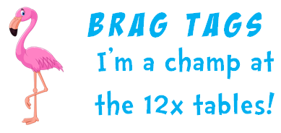

7 x Tables
Criteria for this Brag Tag
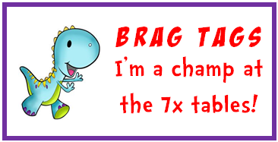 | To get this brag tag you need to answer the 7 x tables problem sheet in front of a teacher. You must do this in under 1.30 minutes. Then a teacher will give you 13 table questions you need to answer quickly so we know you’ve got these in your memory.
Procedure for Assessment
To get this brag tag students must:
- Solve all the tables problems on the sheet (in folder) in under 1.30mins
- Answer the following table questions orally (no more than 5 seconds each one)

7x Tables | 7x Tables | 7x Tables | Answers
7 x 6 =  7 x 4 =  7 x 1 =  7 x 3 =  7 x 11 =  7 x 12 =  7 x 2 =  7 x 9 =  7 x 0 =  7 x 5 =  7 x 8 =  7 x 7 =  7 x 10 = | 7 x 6 =  7 x 4 =  7 x 1 =  7 x 3 =  7 x 11 =  7 x 12 =  7 x 2 =  7 x 9 =  7 x 0 =  7 x 5 =  7 x 8 =  7 x 7 =  7 x 10 = | 7 x 6 =  7 x 4 =  7 x 1 =  7 x 3 =  7 x 11 =  7 x 12 =  7 x 2 =  7 x 9 =  7 x 0 =  7 x 5 =  7 x 8 =  7 x 7 =  7 x 10 = | 7 x 6 = 42  7 x 4 = 28  7 x 1 = 7  7 x 3 = 21  7 x 11 = 77  7 x 12 = 84  7 x 2 = 14  7 x 9 = 63  7 x 0 = 0  7 x 5 = 35  7 x 8 = 56  7 x 7 = 49  7 x 10 = 70

10 Shapes
Criteria for this Brag Tag
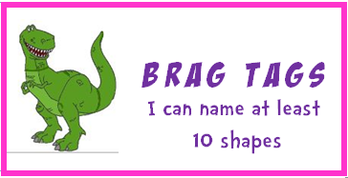 | To get this brag tag you need to list at least 10 shapes, then name the shapes on the flash cards.
Procedure for Assessment
To get this brag tag students must include:
- Square, circle, triangle, rhombus, oval, rectangle, pentagon, octagon, trapezoid, hexagon
- Name the flash cards (in folder) correctly

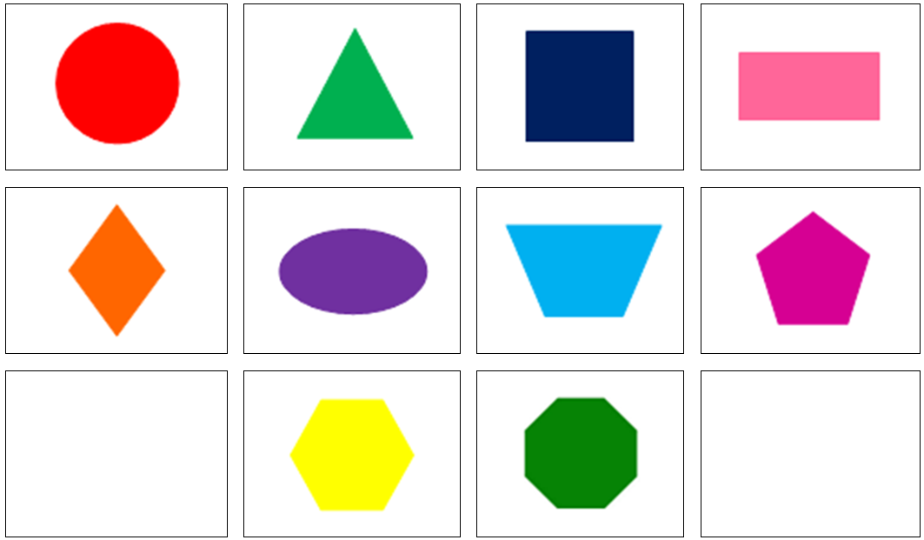

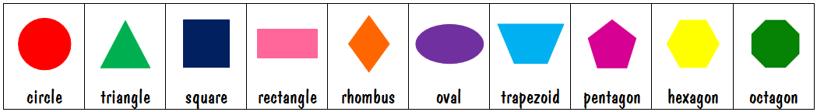

6 Solids
Criteria for this Brag Tag
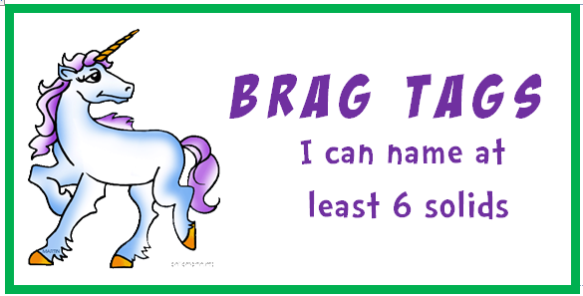 | To get this brag tag you need to name at least 6 solids, then name the solids on the flash cards.
Procedure for Assessment
To get this brag tag students must include:
Cone, sphere, pyramid, rectangular prism, cube, cylinder
Name the flash cards (in folder) correctly

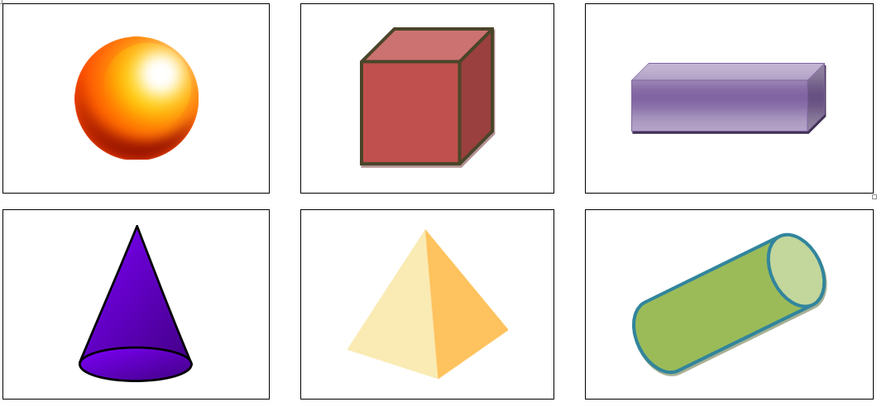

cube | rectangular prism | cone | pyramid | sphere | cylinder

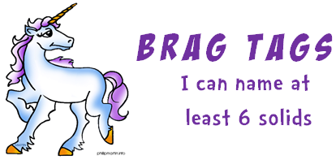

Measurement
Criteria for this Brag Tag
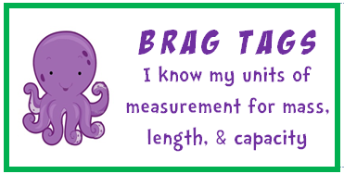 | To get this brag tag you need to answer the 6 questions given to you about length, mass (weight) and capacity. You will need to know the common units each one uses to measure. Eg. Length is measured in millimetres, centimetres, metres and kilometres.
Procedure for Assessment
Ask the following questions:
- What 4 units do we use to measure length?
- Millimetres, centimetres, metres and kilometres – (doesn’t matter what order)
- What 2 units do we use to measure mass? (weight)
- Grams, kilograms
- What 2 units do we use to measure capacity?
- Millilitres, litres
- What type of measuring are we doing if we use millilitres, litres?
- Capacity
- What type of measuring are we doing if we use millimetres, centimetres, metres and kilometres?
- Length
- What type of measuring are we doing if we use grams, kilograms?
- Mass or Weight (either)

Square Numbers
Criteria for this Brag Tag
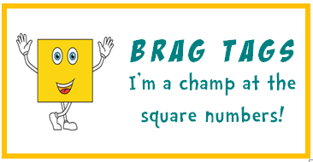 | To get this brag tag you need to answer the square numbers problem sheet in front of a teacher. You must do this in under 1.30 minutes. Then a teacher will give you 13 questions you need to answer quickly so we know you’ve got these in your memory.
Procedure for Assessment
To get this brag tag students must:
- Solve all the problems on the sheet (in folder) in under 1.30mins
- Answer the following questions orally (no more than 5 seconds each one)

Square Numbers | Square Numbers | Square Numbers | Answers
___ x ___ = 36  ___ x ___ = 4  ___ x ___ = 64  ___ x ___ = 81  ___ x ___ = 25  ___ x ___ = 49  ___ x ___ = 100  ___ x ___ = 0  ___ x ___ = 16  ___ x ___ = 1  ___ x ___ = 9  ___ x ___ = 121  ___ x ___ = 144 | ___ x ___ = 36  ___ x ___ = 4  ___ x ___ = 64  ___ x ___ = 81  ___ x ___ = 25  ___ x ___ = 49  ___ x ___ = 100  ___ x ___ = 0  ___ x ___ = 16  ___ x ___ = 1  ___ x ___ = 9  ___ x ___ = 121  ___ x ___ = 144 | ___ x ___ = 36  ___ x ___ = 4  ___ x ___ = 64  ___ x ___ = 81  ___ x ___ = 25  ___ x ___ = 49  ___ x ___ = 100  ___ x ___ = 0  ___ x ___ = 16  ___ x ___ = 1  ___ x ___ = 9  ___ x ___ = 121  ___ x ___ = 144 | 6 x 6 = 36  2 x 2 = 4  8 x 8 = 64  9 x 9 = 81  5 x 5 = 25  7 x 7 = 49  10 x 10 = 100  0 x 0 = 0  4 x 4 = 16  1 x 1 = 1  3 x 3 = 9  11 x 11 = 121  12 x 12 = 144

9 x Tables
To get this brag tag you need to answer the 9 x tables problem sheet in front of a teacher. You must do this in under 1.30 minutes. Then a teacher will give you 13 table questions you need to answer quickly so we know you’ve got these in your memory.
6 x Tables
To get this brag tag you need to answer the 6 x tables problem sheet in front of a teacher. You must do this in under 1.30 minutes. Then a teacher will give you 13 table questions you need to answer quickly so we know you’ve got these in your memory.
8 x Tables
To get this brag tag you need to answer the 8 x tables problem sheet in front of a teacher. You must do this in under 1.30 minutes. Then a teacher will give you 13 table questions you need to answer quickly so we know you’ve got these in your memory.
12 x Tables
To get this brag tag you need to answer the 12 x tables problem sheet in front of a teacher. You must do this in under 1.30 minutes. Then a teacher will give you 13 table questions you need to answer quickly so we know you’ve got these in your memory.
7 x Tables
To get this brag tag you need to answer the 7 x tables problem sheet in front of a teacher. You must do this in under 1.30 minutes. Then a teacher will give you 13 table questions you need to answer quickly so we know you’ve got these in your memory.
10 Shapes
To get this brag tag you need to list at least 10 shapes, then name the shapes on the flash cards.
6 Solids
To get this brag tag you need to name at least 6 solids, then name the solids on the flash cards.
Measurement
To get this brag tag you need to answer the 6 questions given to you about length, mass (weight) and capacity. You will need to know the common units each one uses to measure. Eg. Length is measured in millimetres, centimetres, metres and kilometres.
Square numbers
To get this brag tag you need to answer the square numbers problem sheet in front of a teacher. You must do this in under 1.30 minutes. Then a teacher will give you 13 questions you need to answer quickly so we know you’ve got these in your memory.

