Brag Tag
~ Grade 3 & 4 MD MdJ ~
2019
 | Grade | Friends of 10 | Friends of 20 | Even Numbers  Counting by 2s | Odd Numbers  Counting by 2s | Counting by 5s  – in the hundreds | Counting backwards by 10s | More and Less | Greater Than, Less Than
 | 3
 | 3
 | 3
 | 3
 | 3
 | 3
 | 3
 | 3
 | 3
 | 4
 | 4
 | 4
 | 4
 | 4
 | 4
 | 4
 | 4
 | 4
 | 4
 | 4

Friends of 10
Criteria for this Brag Tag (read to students)
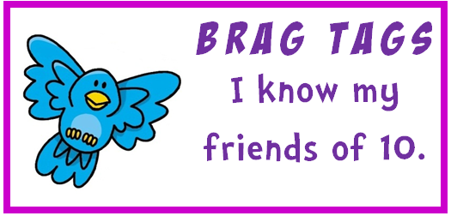 | To get this brag tag you need to write all the friends of ten in front of a teacher. There are 11 of them. They don’t have to be written in order but it’s easier if you do. You must do this in under 1.30 minutes. Then a teacher will call out 5 to you (like ‘1 + what makes 10?’, ‘7 + what makes 10?’) and you need to answer within 5 seconds.
Procedure for Assessment
To get this brag tag students must:
- Write all 11 friends of 10
- They must write the complete sum
- They don’t have to be in order but kids will find it easier if they do
- Writing can take no longer than 1.30 minutes
0 + 10 = 10  1 + 9 = 10  2 + 8 = 10  3 + 7 = 10  4 + 6 = 10  5 + 5 = 10 |  | 6 + 4 = 10  7 + 3 = 10  8 + 2 = 10  9 + 1 = 10  10 + 0 = 10
- Answer the following orally (students only have 5 seconds to answer each one)
- 1 and what makes 10? ( 9 )
- 7 and what makes 10? ( 3 )
- What and 4 makes 10? ( 6 )
- 0 and what makes 10? ( 10 )
- What and 2 makes 10? ( 8 )

Friends of 20
Criteria for this Brag Tag (read to students)
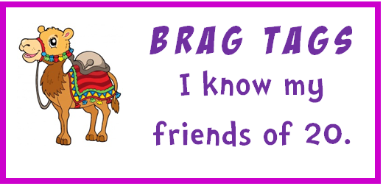 | To get this brag tag you need to write all the friends of twenty in front of a teacher. There are 21 of them. They don’t have to be written in order but it’s easier if you do. You must do this in under 3 minutes. Then a teacher will call out 8 to you (‘like 1 + what makes 20?’, ‘17 + what makes 20?’) and you need to answer within 5 seconds.
Procedure for Assessment
To get this brag tag students must:
- Write all 21 friends of 20
- They must write the complete sum
- They don’t have to be in order but kids will find it easier if they do
- Writing can take no longer than 3 minutes
0 + 20 = 20  1 + 19 = 20  2 + 18 = 20  3 + 17 = 20  4 + 16 = 20  5 + 15 = 20  6 + 14 = 20  7 + 13 = 20  8 + 12 = 20  9 + 11 = 20  10 + 10 = 20 |  | 11 + 9 = 20  12 + 8 = 20  13 + 7 = 20  14 + 6 = 20  15 + 5 = 20  16 + 4 = 20  17 + 3 = 20  18 + 2 = 20  19 + 1 = 20  20 + 0 = 20
- Answer the following orally (students only have 5 seconds to answer each one)
- 10 and what makes 20? ( 10 )  - 7 and what makes 20? ( 13 )  - What and 16 makes 20? ( 4 )  - 0 and what makes 20? ( 20 ) |  | - What and 2 makes 20? ( 18 )  - What and 15 makes 20? ( 5 )  - 1 and what makes 20? ( 19 )  - What and 17 makes 20? ( 3 )

Even Number Counting by 2s
Criteria for this Brag Tag (read to students)
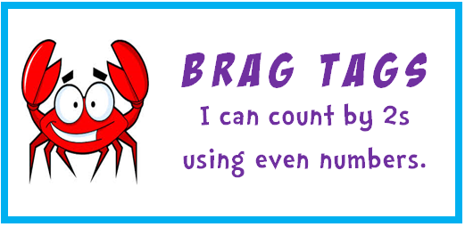 | To get this brag tag you need to listen to the starting number you are given then count by twos from that number until you’re told to stop. You can do this by writing or saying the numbers.
Procedure for Assessment
To get this brag tag:
- Give the student a starting point:
- For Grade 3 starting point is 42 For Grade 4 starting point is 184
- Students may say or write the next 12 numbers
- Grade 3: 44 46 48 50 52 54 56 58 60 62 64 66
- Grade 4: 184 186 188 190 192 194 196 198 200 202 204 206
- Kids should be fairly fluent (!)
- If students are unsuccessful and wish to try again, give them a different starting number

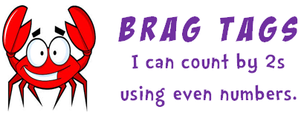

Odd Number Counting by 2s
Criteria for this Brag Tag (read to students)
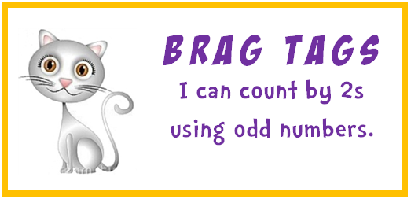 | To get this brag tag you need to listen to the starting number you are given then count by twos from that number until you’re told to stop. You can do this by writing or saying the numbers.
Procedure for Assessment
To get this brag tag:
- Give the student a starting point:
- For Grade 3 starting point is 33 For Grade 4 starting point is 125
- Students may say or write the next 12 numbers
- Grade 3: 35 37 39 41 43 45 47 49 51 53 55 57
- Grade 4: 127 129 131 133 135 137 139 141 143 145 147 149
- Kids should be fairly fluent (!)
- If students are unsuccessful and wish to try again, give them a different starting number

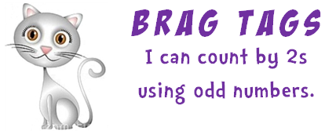

Counting by 5s – in the hundreds
Criteria for this Brag Tag (read to students)
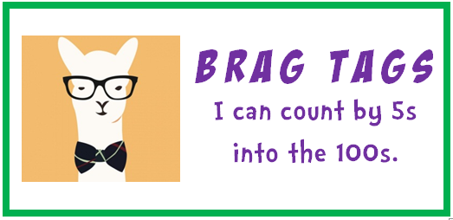 | To get this brag tag you need to listen to the starting number you are given then count by fives from that number until you’re told to stop. You can do this by writing or saying the numbers.
Procedure for Assessment
To get this brag tag:
- Give the student a starting point:
- For Grade 3 starting point is 65 For Grade 4 starting point is 175
- Students may say or write the next 12 numbers
- Grade 3: 70 75 80 85 90 95 100 105 110 115 120 125
- Grade 4: 180 185 190 195 200 205 210 215 220 225 230 235
- Kids should be fairly fluent (!)
- If students are unsuccessful and wish to try again, give them a different starting number

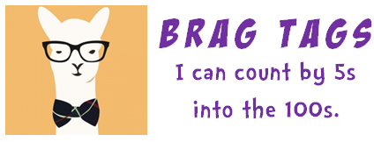

Counting backwards by 10s
Criteria for this Brag Tag (read to students)
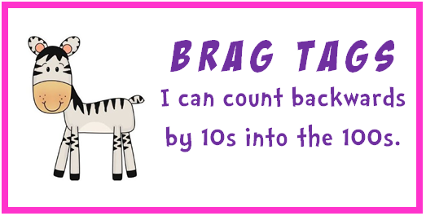 | To get this brag tag you need to listen to the starting number you are given then count backwards by tens from that number until you’re told to stop. You can do this by writing or saying the numbers.
Procedure for Assessment
To get this brag tag:
- Give the student a starting point:
- For Grade 3 starting point is 380 For Grade 4 starting point is 830
- Students may say or write the next 12 numbers
- Grade 3: 380 370 360 350 340 330 320 310 300 290 280 270
- Grade 4: 830 820 810 800 790 780 770 760 750 740 730 720
- Kids should be fairly fluent (!)
- If students are unsuccessful and wish to try again, give them a different starting number

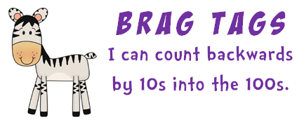

More and Less
Criteria for this Brag Tag (read to students)
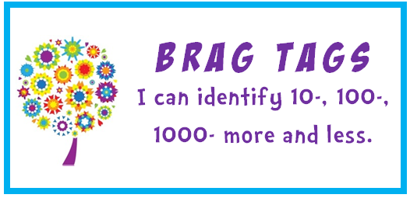 | To get this brag tag, when given a 2-, 3- or 4- digit number, you need to identify 10 more, 100 more, 1000 more, 10 less, 100 less, 1000 less than the number.
Procedure for Assessment
To get this brag tag:
- Give the student a 2-, 3- and 4- digit number (supplied).
- Students may say or write the 10 more, 100 more, 1000 more, 10 less, 100 less, 1000 less than for each number.
- Kids may use the ‘How Much is 1000?’ book to help.
- If students are unsuccessful and wish to try again, give them different numbers.
Your number is 42.  What is 10 more?  52  What is 100 more?  142  What is 1000 more?  1 042  What is 10 less?  32 |  | Your number is 743.  What is 10 more?  753  What is 100 more?  843  What is 1000 more?  1743  What is 10 less?  733  What is 100 less?  643 | Your number is 2 085.  What is 10 more?  2 095  What is 100 more?  2 185  What is 1000 more?  3 085  What is 10 less?  2 075  What is 100 less?  1 985 (hard one)  What is 1000 less?  1 085

Greater Than, Less Than
Criteria for this Brag Tag (read to students)
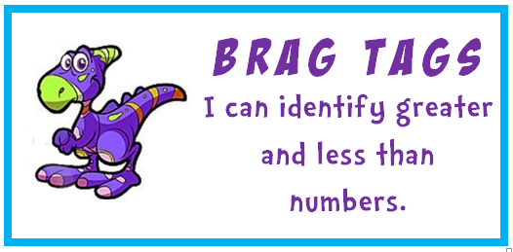 | To get this brag tag you will be given a series of 2 numbers and you need to identify greater than and less than, by telling and by using the symbols < > .
Procedure for Assessment
To get this brag tag:
- Give the student a set of 6 number cards showing pairs of numbers (supplied).
- Students must take each card and make a statement - *** is greater than *** or *** is less than ***, reading from left to right.
- Students then write the two numbers putting a > or < in between.
- If students are unsuccessful and wish to try again, give them different numbers.

45 73 |  |  | 62 26
487 399 |  |  | 305 930
1 280 6 732
< | < | < | > | > | >

45 is less than 73 | 62 is greater than 26
487 is greater than 398 | 305 is less than 930
1 280 is less than 6 732

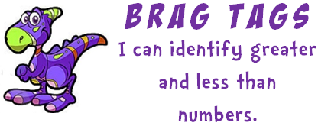

Friends of 10
To get this brag tag you need to write all the friends of ten in front of a teacher in under 1.30 minutes (Hint: it’s easier to do it in order). Then a teacher will call out 5 to you and you need to answer within 5 seconds
Friends of 20
To get this brag tag you need to write all the friends of twenty in front of a teacher in under 3 minutes (Hint: it’s easier to do it in order). Then a teacher will call out 8 to you and you need to answer within 5 seconds.
Even Number Counting by 2s
To get this brag tag you need to listen to the starting number then count by twos from that number until you’re told to stop. You can do this by writing or saying the numbers.
Odd Number Counting by 2s
To get this brag tag you need to listen to the starting number then count by twos from that number until you’re told to stop. You can do this by writing or saying the numbers.
Counting by 5s – in the hundreds
To get this brag tag you need to listen to the starting number then count by fives from that number until you’re told to stop. You can do this by writing or saying the numbers.
Counting backwards by 10s
To get this brag tag you need to listen to the starting number then count backwards by tens from that number until you’re told to stop. You can do this by writing or saying the numbers.
More and Less
To get this brag tag, when given a 2-, 3- or 4- digit number, you need to identify 10 more, 100 more, 1000 more, 10 less, 100 less, 1000 less than the number.
Greater Than, Less Than
To get this brag tag you will be given a series of 2 numbers and you need to identify greater than and less than, by telling and by using the symbols < > .

