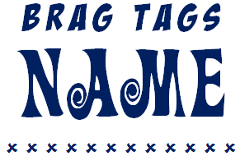

B R A G T A G S  NAME |  | B R A G T A G S  NAME

B R A G T A G S  NAME |  | B R A G T A G S  NAME

B R A G T A G S  NAME |  | B R A G T A G S  NAME

B R A G T A G S  NAME |  | B R A G T A G S  NAME

