Dear Families,
Our class has looked at the work Caritas https://www.caritas.org.au/ does to help people around the world and we were amazed at how much they can do with so little.
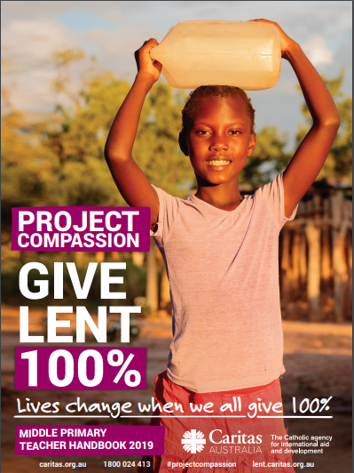
We have 4 small Project Compassion boxes (and 1 big one) in our class and we thought it a great idea to send a box home to each family for 1 week. There are 5 weeks of Lent so each family will have a turn with a box. At the end of the week when the 4 boxes come back, we’ll empty them into the big one, before sending it on to the next family. We’ll keep a tally of how much we raise together (but not individual boxes).

On the final day of Term, we’ll find out how much we’ve raised as a class. We hope you can support us with your ‘spare change’ and generosity. Maybe the students could do a few extra jobs for you to help raise money!

