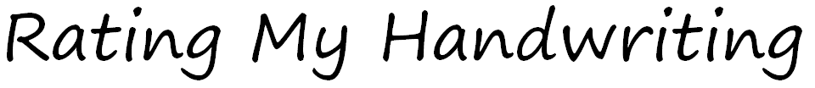
Look carefully through each page. Give yourself a score (out of 3) for each statement and Miss Marg will do the same. Then give yourself a goal to work for next.
I will be successful if… | My score | My teacher’s score
- I am able to sort letters by their formation features. | /3 | /3
- I am able to correctly form letters. | /3 | /3
- I am able to keep my writing ‘sitting’ on the lines. | /3 | /3
- I am able to keep the size of my letters accurate and consistent. | /3 | /3
- I am able to use consistent spacing between letters and words. | /3 | /3
My goal is…

Look carefully through each page. Give yourself a score (out of 3) for each statement and Miss Marg will do the same. Then give yourself a goal to work for next.
I will be successful if… | My score | My teacher’s score
- I am able to sort letters by their formation features. | /3 | /3
- I am able to correctly form letters. | /3 | /3
- I am able to keep my writing ‘sitting’ on the lines. | /3 | /3
- I am able to keep the size of my letters accurate and consistent. | /3 | /3
- I am able to use consistent spacing between letters and words. | /3 | /3
My goal is…

