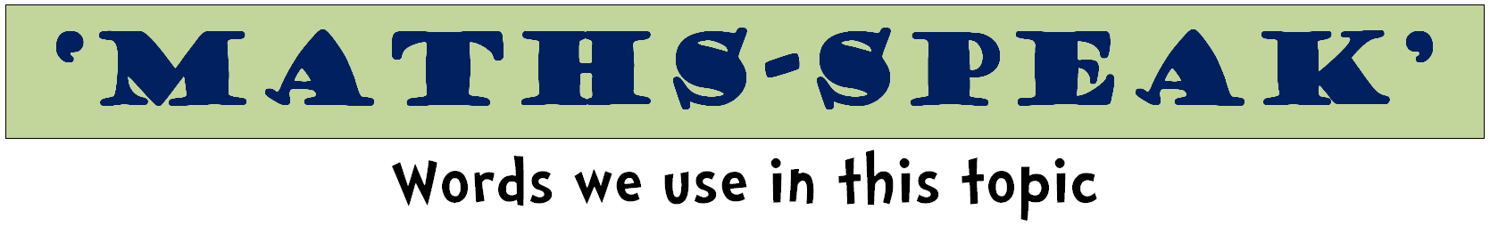
Shapes & Solids
circle | semi-circle |  | oval
triangle | square |  | rectangle
pentagon | hexagon |  | octagon
rhombus | parallelogram |  | trapezoid
shape | two-dimensional
solid | three-dimensional
prism | sphere |  | cube
cylinder | cone |  | pyramid
triangular prism |  | rectangular prism
flip | slide |  | turn
diagram | net |  | model

base | face | surface
vertices | point | apex
edge | line | side
angle | 2D | 3D
shape | solid | hollow
corner | size | flat
rectangular | circular | triangular
straight | curved | round
line of symmetry, symmetrical

angle | degree | vertex
right angle | point | diagram
acute | obtuse | reflex
shape | base | protractor

