Plan for Writing a Narrative
Who is in my story? | What are they doing? | Where is this happening? | When does this happen?
What’s the problem? |  | How do they solve it?

Plan for Writing a Recount
Event:
Who? | What? | When? | Where?
Order of Events (1st, 2nd, 3rd etc)

Plan for Writing a Procedure
Finished product will be:
List of ingredients/equipment (with quantities)
Steps / Method: (brief notes)

Plan for Writing a Persuasive Text
Issue:

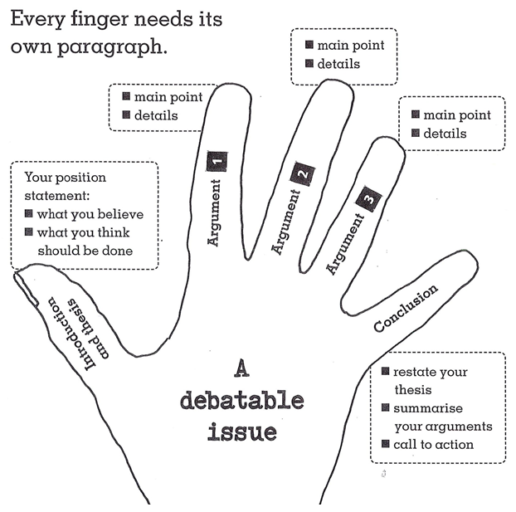
Arguments and Evidence (in dot points)

Plan for Writing a Report
Use a spider planner to jot down your ideas into groups before writing.
(See your teacher if you need a bigger one)

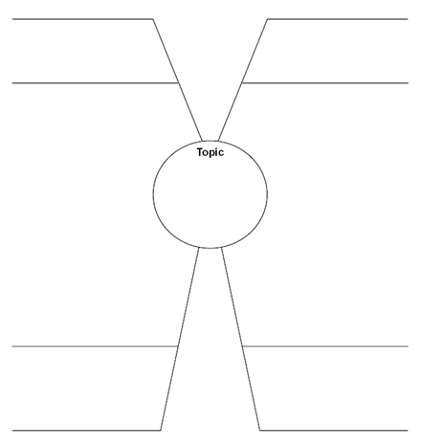

Plan for Writing a Limerick
Ideas:
Rhyming words I could use:

1st 2nd and last lines 3rd and 4th line

