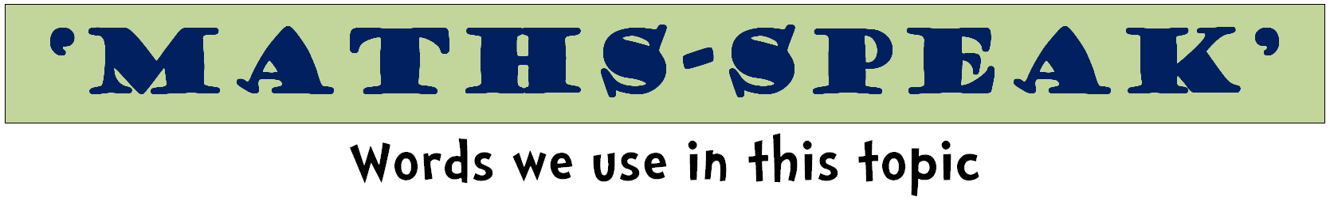
whole | part |  | fraction
equal parts | half |  | halves
thirds | quarters |  | fourths
fifths | sixths |  | sevenths
eighths | ninths |  | tenths
numerator |  | denominator

point | zero | naught
tenths | hundredths | thousandths

unit | ones | tens
hundreds | thousands | millions
digit | place | value
represent | base 10 | exchange

