1  2 | 1  3 | 1  4 | 1  5
2  3 | 3  4 | 2  5 | 3  5
5  6 | 3  10 | 1  10 | 1  8
5  8 | 7  8 | 1  6 | 3  6

five  sixths | one  quarter | one  third | seven  eighths
three  sixths | five  eighths | one  sixth | one  fifth
one  half | one  eighth | three  tenths | three  quarters
two  thirds | three  fifths | two  fifths | one  tenth

 | 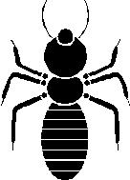 |  | 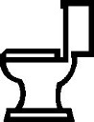
 |  | 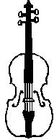 | 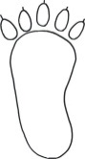

1  2 | 1  3 | 1  4 | 1  5
2  3 | 3  4 | 2  5 | 3  5
5  6 | 3  10 | 1  10 | 1  8
5  8 | 7  8 | 1  6 | 3  6
five  sixths | one  quarter | one  third | seven  eighths
three  sixths | five  eighths | one  sixth | one  fifth
one  half | one  eighth | three  tenths | three  quarters
two  thirds | three  fifths | two  fifths | one  tenth

