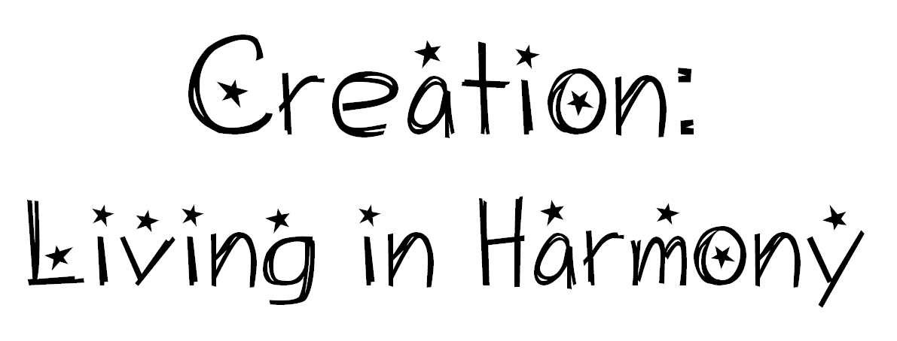

Seeking Discoveries
How do the choices we make about the environment affect people in other places?
Why is it important for Christians to use the earth justly?

Understandings:
The environment is given by God to be used and shared by all people.
Jesus Christ showed us how to live in harmony with God, creation and others.
The choices we make about how we use the environment can have positive or negative effects on people and environments in other places.
All people have a right to share in the goods of creation.
The choices we make about how we use the earth and its resources need to be just for all people.

Scripture Text
Ps 148: 1–4; Lk 14: 12–24.

