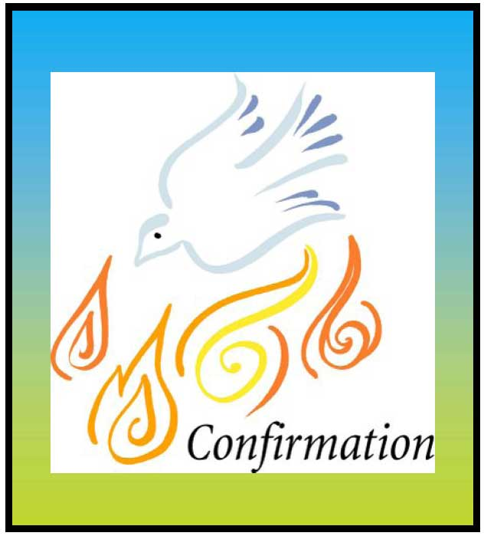
School

Date

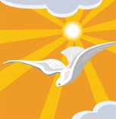
Come, Holy Spirit,
fill the hearts of your faithful,
and kindle in them
the fire of your love.

Send forth your Spirit
and they shall be created,
And you will renew
the face of the earth.

