We’re Learning About Blends

Learning about blends helps us to spell words correctly and increases our vocabulary.

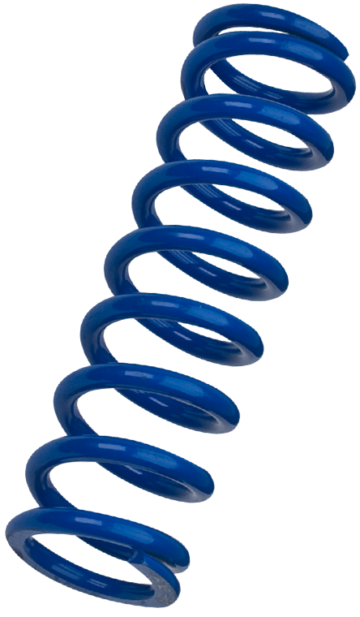
Words that begin with
spr

What words have a ‘spr’ blend?
Would a dictionary help?

What words have a ‘spr’ blend?

spring | sprint | spray
spread | sprinkle

Word Search for ‘spr’ Blend Words
J L O K Z U C J G L R Y O C G  T R K L W D N R V N Q X V U W  B T X W A C U R I T I G H R J  O V T E I K Q P H D Y R O F M  V K R G O G T I A A Q H P F N  F P L E L E N J C W S P D S R  S K L E D V I E G L O G U X D  S P R A Y W R W X R Z R M I D  E L K N I R P S F B F Y M G Q  R Q I K Y L S H L Y E A U S P  U R S C W U Q M P G N K K D A  R Q V C H R J R C O B Z N O J  N Q D C A H G V X S T I I Z U  G Q X Q A P F D K D V Y L V M  A I A U U W X N M L J V V Z L | SPRING  SPRINT  SPRAY  SPREAD  SPRINKLE

Make a Flip Book

spr

Words you can do  (Verbs) | Words that are something  (Nouns)
Words that describe something  (Adjectives) | Not sure

