We’re Learning About Blends

Learning about blends helps us to spell words correctly and increases our vocabulary.

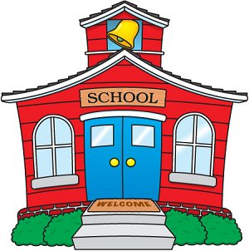
Words that begin with
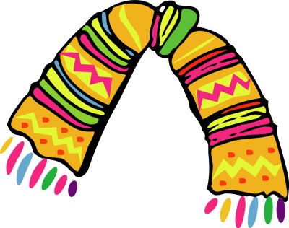
sc

What words have a ‘sc’ blend?
Would a dictionary help?

What words have a ‘sc’ blend?

scare | score | scout
scan | scarf | school

Word Search for ‘sc’ Blend Words
E R A C S S E R T L J L Y X H  F G A V C Z B R R D P R N R D  D L I H C U A Y O F Q H C F K  S X O C I M F J V C B H V S Y  G O I K Q D Z P X E S P Z K C  L F M G W B K F V S E Z Q F K  B N U V G Y O T I O N K R P C  F W D E F M T D B Z J A B D N  P Y W D N T J G F U C D L Q A  H S S G M U U R W S C A N K F  H P N A U O Z F R W U X K G Y  S O H N C C I U F X P D T R J  V V C B Z S F X E F X S J Y X  K Q P X O Q J O I P Z N J C Z  F C I C T I P T S W X C T Q D | SCARE  SCORE  SCOUT  SCAN  SCARF  SCHOOL

Make a Flip Book

sc

Words you can do  (Verbs) | Words that are something  (Nouns)
Words that describe something  (Adjectives) | Not sure

Sarah’s old scarecrow
has a long scarlet scarf,
She polished his buttons
then gave him a bath.
When she tickled his tummy
it made scarecrow laugh.

