We’re Learning About Blends

Learning about blends helps us to spell words correctly and increases our vocabulary.

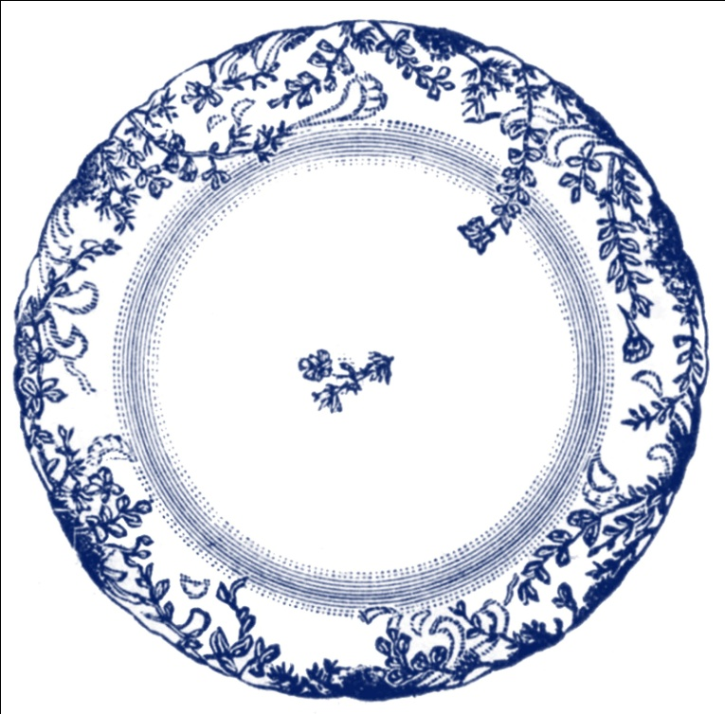
Words that begin with
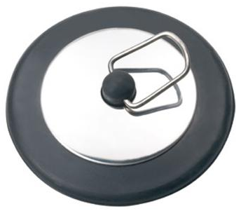
pl

What words have a ‘pl’ blend?
Would a dictionary help?

What words have a ‘pl’ blend?

plain | place | plan
plate | plant | play
planet | plum | plug
plus | plenty | please

Word Search for ‘pl’ Blend Words
K P X Z E R L H M C P J G X L  X H L Y Z S X J T L C F A P Y  L A K A Z Y C S A E T U M L T  J J H A C T A N O B N F A A N  P L A I N E T L J A F A S T E  T V D B P D E L P G E F L E L  L G B Y M U U W U R Q G P P P  E C D N A E Z L N P J P Y N B  D P F P S A P Q H C U B C O A  Q T Q A Z R I S D A B M G T B  E L E R X U D Y J X L M N D V  E L A K F T P C Y G N A L P M  P L U S D Q M U L B X G X K U  C O U O P C D C N D Y W U A L  M A K C R K O D F W A D K H P | PLAIN  PLACE  PLAN  PLATE  PLANT  PLAY  PLANET  PLUM  PLUG  PLUS  PLENTY  PLEASE

Make a Flip Book

pl

Words you can do  (Verbs) | Words that are something  (Nouns)
Words that describe something  (Adjectives) | Not sure

My friends and I play pirates,
We make great pirate ships.
We walk the plank,
and wave our flags,
and laugh when someone slips...
Plop!

