We’re Learning About Blends

Learning about blends helps us to spell words correctly and increases our vocabulary.

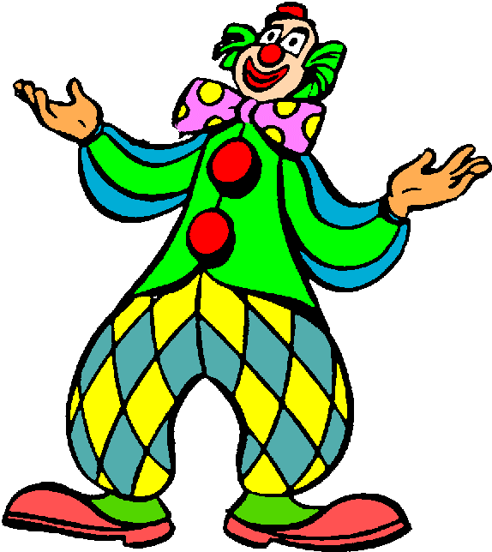
Words that begin with
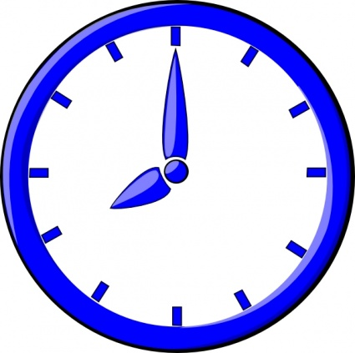
cl

What words have a ‘cl’ blend?
Would a dictionary help?

What words have a ‘cl’ blend?

cloth | class | clay
close | climb | club
clock | clown | click
clear

Word Search for ‘cl’ Blend Words
T V C E F V B K B X E O I C D  O I M L K S Z L J Y M R R L B  D V X N I K G H U T A U W O Z  R F R C H M W F B H T M R C B  Q A Q I T I B K C I L C S K K  J X E I O M G L Y I L S L B G  Q Z C L L I O D A L A C N D A  X T X T C W Z V L L B M N N H  Z N B B N C R K C Q U H N M Z  Y G U T B F D E A C L O S E Z  H L N O X I O K N Y F Y Q N X  C Z S H E U O C S N Q M I T Y  S K I V J Q K R Y T T V X S M  Z U G Q Q T F N T D T W B P I  J B G B T P Y K P Q G D T L F | CLOTH  CLASS  CLAY  CLOSE  CLIMB  CLUB  CLOCK  CLOWN  CLICK  CLEAR

Make a Flip Book

cl

Words you can do  (Verbs) | Words that are something  (Nouns)
Words that describe something  (Adjectives) | Not sure

Clever clowns hang upside down.
Clowns with clocks
and silly socks...
This climbing clown
Just can’t come down!

