We’re Learning About Blends

Learning about blends helps us to spell words correctly and increases our vocabulary.

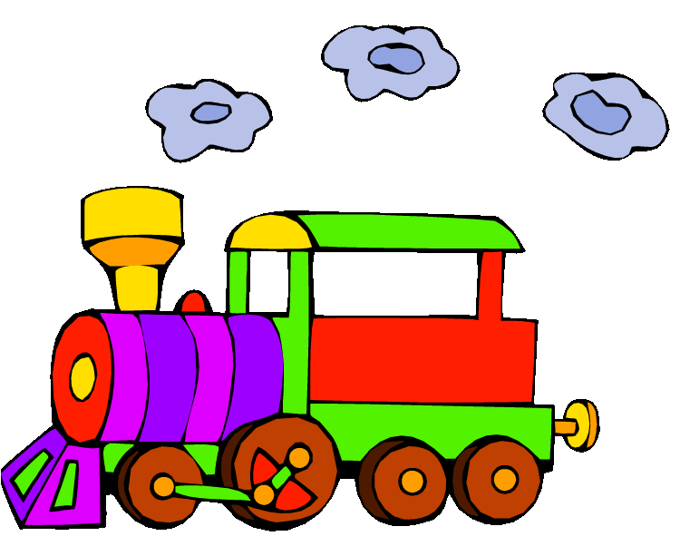
Words that begin with
tr

What words have a ‘tr’ blend?

track | train | trade
tram | trip | traffic
trick | trim | trap
truck | true | tree

Word Search for ‘tr’ Blend Words
V S J T F K J B X E T W M A W  T W O V R M C A I R B L I W G  R R M D J A W U E O B L K V U  U T E Z L W P E R T K C I R T  E K S L A A E T Q T X I T T F  S T O L J M P H G F U R A E C  L S R S F A V R H P A I C V M  C W J A L R T M I D T R I M Z  J U I C C T K R E T K F I M C  S I H G R K T J Q I T I F Y Y  E N N U A J F J R O R Q M G Y  F T S D F J K A L A A Q U V C  A F C A L Q Z A M J I J D O I  M G F R K P Z E W P N A H H Q  K U X J M U N F N N Z V O X O | TRACK  TRAIN  TRADE  TRAM  TRIP  TRAFFIC  TRICK  TRIM  TRAP  TRUCK  TRUE  TREE

Make a Flip Book

tr

Words you can do  (Verbs) | Words that are something  (Nouns)
Words that describe something  (Adjectives) | Not sure

Tractors, trucks, trains
and trams.
In the city
traffic jams!

What words have a ‘tr’ blend?
Would a dictionary help?

