We’re Learning About Blends

Learning about blends helps us to spell words correctly and increases our vocabulary.

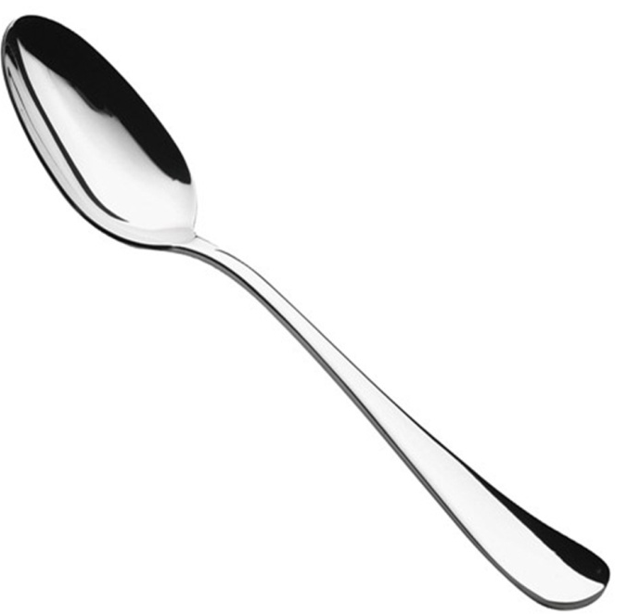
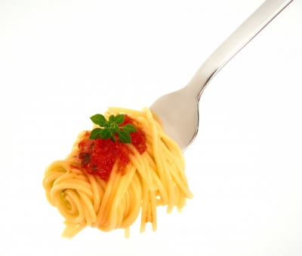
Words that begin with
sp

What words have a ‘sp’ blend?

spend | spot | spin
spoon | spirit | sport
speak | space | spent
speech | speed | spoke

Word Search for ‘sp’ Blend Words
F F X M T S S E P Y A L S B N  Q E R S A P S P E E D T N P L  T M P P D O T K E S N H A O U  Z I O B A T J L R E P Y Q Q Q  N V E Z Y U F N P K C O T L J  D W C I X V W S I O A H K H H  S H A N S L N Y J Z V E R E N  U S P Z W D S C H S S G P T Y  M V S N I P B P C K P N C S K  Q D Y Y H A J U T T W K N S R  S H A X W K D S M P C P U P Z  S P I R I T P F S J V I N E R  T R O P S O W L Y P B Q I N N  G K G I O D S M I J U H F D X  T Y V N R X L R L Y O X A M F | SPEND  SPOT  SPIN  SPOON  SPIRIT  SPORT  SPEAK  SPACE  SPENT  SPEECH  SPEED  SPOKE

Make a Flip Book

sp

Words you can do  (Verbs) | Words that are something  (Nouns)
Words that describe something  (Adjectives) | Not sure

You need a spoon
to eat spaghetti,
You need a spacesuit
to go spacewalking,
and you need springy shoes
to be a sports star!
What words have a ‘sp’ blend?
Would a dictionary help?

