We’re Learning About Blends

Learning about blends helps us to spell words correctly and increases our vocabulary.

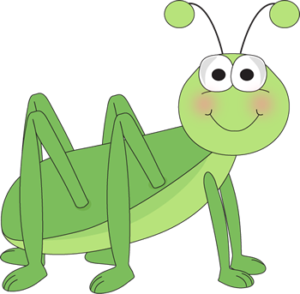
Words that begin with
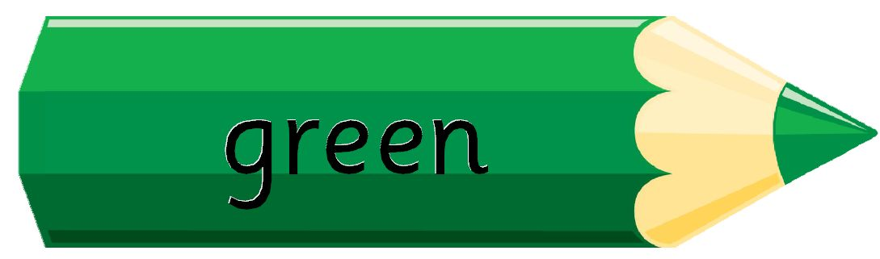
gr

What words have a ‘gr’ blend?

grab | grade | grand
grape | grandma | grass
great | grew | group
ground | green

Word Search for ‘gr’ Blend Words
L S G E P V X W N T A K A P Z  P D R M A C J E Y K A M S U E  U G A H Q D E G H C D E K O F  W F N A X R L V R N F G R R W  I S D L G R Y B A A Y O H G C  V J V B M Z N R O L D W Y L P  G R A B G K G O X M A E D D B  Y S U M U R H D G X L F U N P  E S K Y E C E Q I B K V P X Z  S S A R G D D W F N H G O S F  X S H R E B E N M B R M T R C  U W I H E A G X L A D K W L X  A K X L U F J N P N R J V Z H  V W Y N W O N E W S P U Z W U  N I Q G R O U N D O I U S A A | GRAB  GRADE  GRAND  GRAPE  GRANDMA  GRASS  GREAT  GREW  GROUP  GROUND  GREEN

Make a Flip Book

gr

Words you can do  (Verbs) | Words that are something  (Nouns)
Words that describe something  (Adjectives) | Not sure

Grandma likes cats
and Grandpa likes dogs.
Greg likes green grasshoppers
but I like green frogs.

What words have a ‘gr’ blend?
Would a dictionary help?

