We’re Learning About Blends

Learning about blends helps us to spell words correctly and increases our vocabulary.

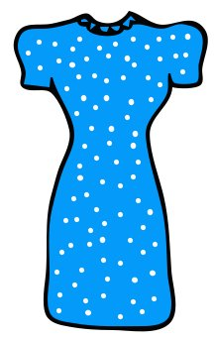
Words that begin with
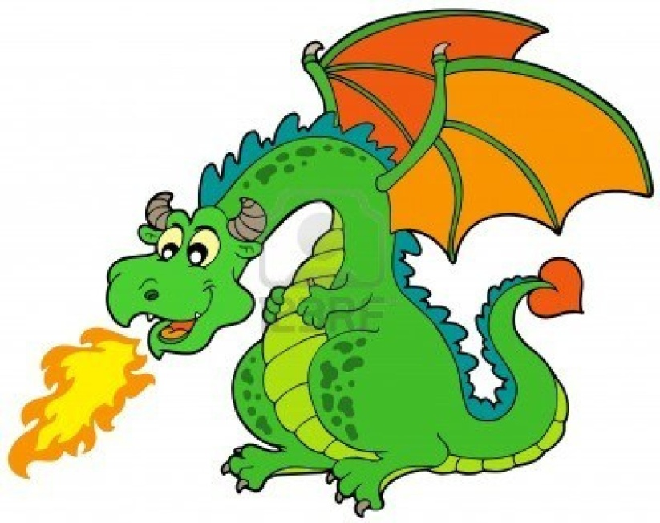
dr

What words have a ‘dr’ blend?

drag | dream | drank
drive | drove | drum
drink | drill | drug
dress | drop

Word Search for ‘dr’ Blend Words
G C F F T D A G D E D O D B X  H U E N W J G M V O R U U U F  J Q R Y C Z K O Z W E Z I O P  A X C D N V R C R K S P X O D  E S N M D D K X W J S M M A O  I C E E M X U Z R T M U R D D  M P Y V X K P R Q R O S A E L  K L B I R I X R G P F N S L F  C N J R M K B P B R Z V L T I  I M A D J Q E O D C R X P B D  M A E R D D R R G M V Y N W D  N Q I V D Q R D N I B M R R C  L Q J O P R D I Y M W D A R N  D R I N K L Q P L O Z G Z Q O  D O J D F E H P R L O U B J J | DRAG  DREAM  DRANK  DRIVE  DROVE  DRUM  DRINK  DRILL  DRUG  DRESS  DROP

Make a Flip Book

dr

Words you can do  (Verbs) | Words that are something  (Nouns)
Words that describe something  (Adjectives) | Not sure

I like to draw dragons,
I like to dress up.
And I like singing songs
with the music turned up
But I love to dream
that I’m a drummer...
What words have a ‘dr’ blend?
Would a dictionary help?

