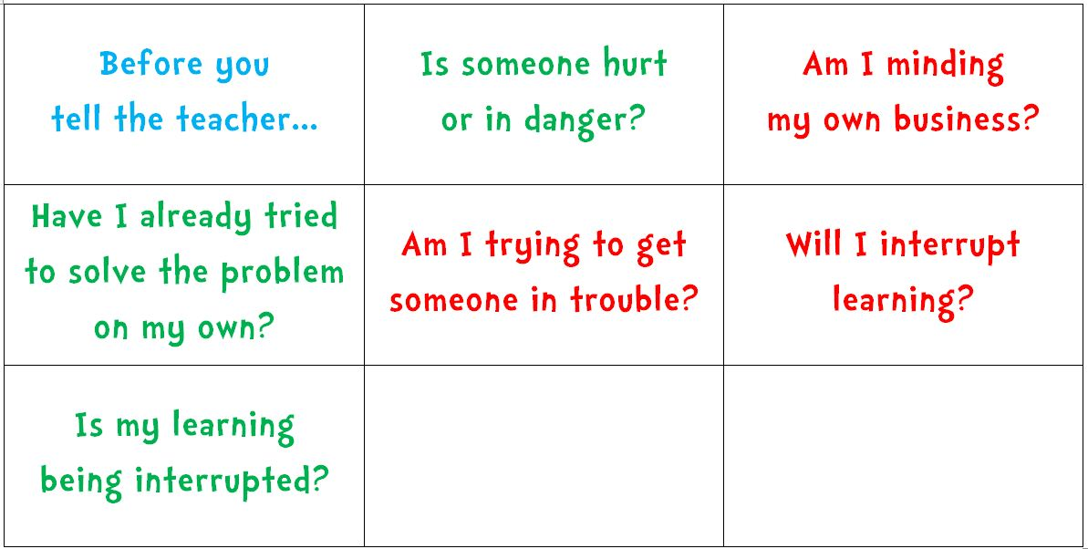

Laminate, cut and hole punch the top corner and bind together with a key ring or paperclip, so child can have own copy for table, tub or pocket (depending of severity of ‘dobbing’)

MargD

